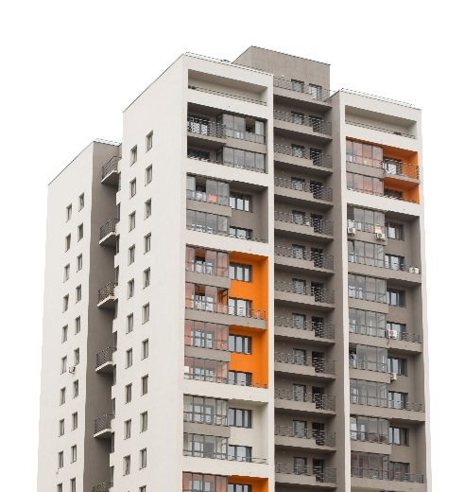

The Block

This project is designed to allow you to use as much of your new language as you possibly can. Imagine you're a blogger. You live in a flat in a city, in a country where they speak your language. You know the people in your block - they're young, old, single, couples, divorced, families, groups of students; some have lots of kids, some have none, some have animals - some vicious, some sweet; some live a frantic life, some a very slow and quiet life. You’re going to create a whole world which gravitates around this block of flats which you will create visually for others to read.

Do this in pairs, or a group if you prefer, but you must be studying the same language.

Negotiate with the whole Language Futures group and your teacher and mentors how long you have to work on this - is it a set number of lessons or is it something you could do across the whole year with time set aside for it about once a month? You decide.

We suggest you think about the whole project first to get an overview. Decide what you will include - you might think about:

- Location - where is The Block? What’s the address? Get a photo, decide how many floors and flats there are in the block, get an address etc.

- The look and feel of the flats - do a floorplan of one of them, work out what a typical flat looks like - do a mock up - colour scheme and style depending on who lives there - cool and minimal, student grungy, complete mess with kids’ stuff all over? You decide.

- Who lives there? Get names for all the inhabitants - decide on family groupings and friendship groupings. You could focus on two lots of people and work out their life style - someone who lives in complete chaos compared to someone else who's compulsively tidy.

- Decide on the relationships people have - who gets on with whom? Are there friends, enemies, kindnesses, vengeances? Can you create a diagram to show the relationships? What’s the cause of strife if there is any? Did something trivial happen that escalated tension?

Create a 90 second drama - an encounter that takes place on the stairs, in the shop, on the ground floor (if you've decided to have one), in the underground car park, in the lift - it could be anywhere, but the key factor is that the protagonists live in the block and there is tension within their relationship. Your presentation could be on a web page or on a wall of the classroom. It’s as if you are creating a fictional world with you at the centre. You’re telling the reader about this world in which you live, about day to day life where you live which, maybe, sometimes isn't plain sailing.

