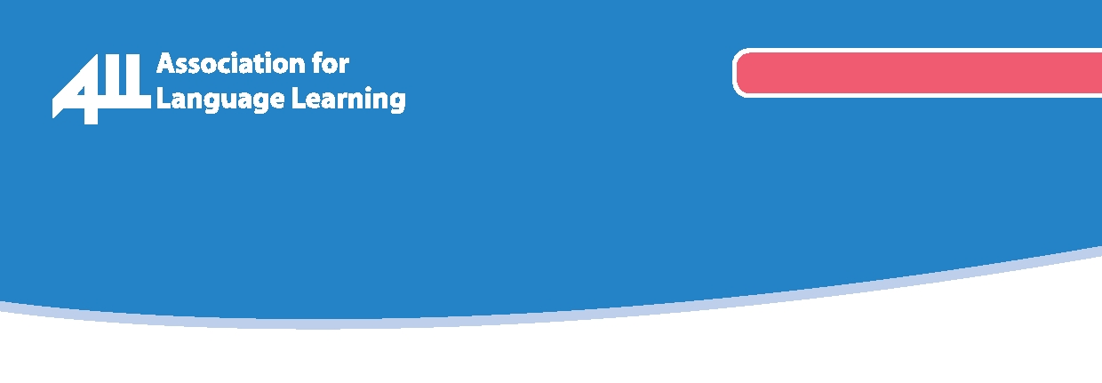
www.all-languages.org.uk

ALL Together Now!

ALL Publications Order Form  (subject to availability) |  |  | Quantity | ALL Member Price | ALL Group Member Price | Non member Price | Total
Curriculum Now! |  |  |  | £12.00 | £15.00 | £20.00
Looking back – moving forward |  |  |  | £5.00 | £5.00 | £7.50
Primary Projects Box |  |  |  | £45.00 | £45.00 | £90.00
Francophonie | issue number: |  |  | £5.00 | £5.00 | £7.50
Deutsch: Lehren & Lernen | issue number: |  |  | £5.00 | £5.00 | £7.50
Vida Hispánica | issue number: |  |  | £5.00 | £5.00 | £7.50
Rusistika | issue number: |  |  | £5.00 | £5.00 | £7.50
Tuttitalia | issue number: |  |  | £5.00 | £5.00 | £7.50
My best 10… strategies for teaching listening |  |  |  | £1.20 | £1.20 | £1.50
My best 10… ways to teach languages through sport |  |  |  | £1.20 | £1.20 | £1.50
My best 10… tips for trainee teachers |  |  |  | £1.20 | £1.20 | £1.50
My best 10… filmmaking websites |  |  |  | £1.20 | £1.20 | £1.50
My best 10… techniques for teaching non-Roman script languages |  |  |  | £1.20 | £1.20 | £1.50
My best 10… ways to use songs to teach languages |  |  |  | £1.20 | £1.20 | £1.50
My best 10… tips for language learning at any age |  |  |  | £1.20 | £1.20 | £1.50
My best 10… tips for CLIL |  |  |  | £1.20 | £1.20 | £1.50
My best 10… ways to teach languages through stories |  |  |  | £1.20 | £1.20 | £1.50
Set of any five posters |  |  |  | £4.00 | £4.00 | £5.00
Your details: Please use BLOCK CAPITALS |  | Total:

Name: ___________________________________________________________________________________
Institution / Organisation: _____________________________________________________________________
Delivery address: ___________________________________________________________________________
____________________________________________________________Postcode: _____________________
Telephone No: ______________________ Email address: ____________________________________________

Payment details:
Credit / debit card details: Name as it appears on the card: ____________________________________________
Cardholder’s address: ________________________________________________________________________
___________________________________________________________________Postcode: ______________
Card no: □□□□ □□□□ □□□□ □□□□ | Valid from: □□/□□
Security code (last three digits on reverse): □□□ | Expiry date: □□/□□
Card type: □ Mastercard □ Switch □ Other: (name) | Issue no (if given): □□

Or payment by cheque: I enclose a cheque for £ payable to the Association for Language Learning.

Alternative payment: Please send an invoice to:
Please send form to: Association for Language Learning, University of Leicester, University Road, Leicester, LE1 7RH, or info@all-languages.org.uk.

