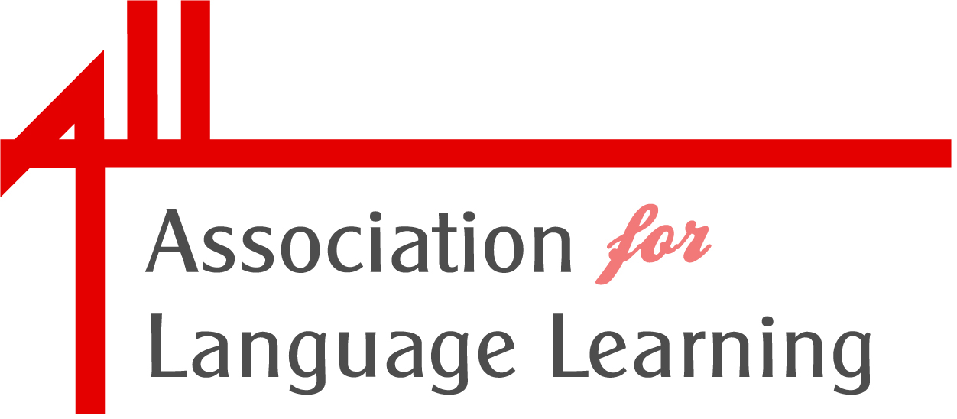

Honorary Membership Officer (HMO) – volunteer role description

The role:

HMO is a very important role within the Association. This is reflected in the fact that the HMO is a member of the board of trustees of ALL (the Management Board) for his/her three years of office. HMO also sits on the ALL Council and chairs the Branch, Network and Hub Forum. The HMO is a key contact with volunteers in these local groups.

The role of HMO is both advisory (on Management Board, with ALL staff) and hands-on (in working with branches, supporting and advising members, representing ALL at appropriate meetings and events).

Term of office: Three years (2016-2018)

Purpose:

- To advise and support the Association, and its staff, in recruiting new members and providing services to members
- To support branches, networks and hubs in providing locally-based activities for ALL members
- To foster collaboration, sharing of ideas and resources between volunteer members

Responsibilities:

The HMO will:

- Support ALL staff in monitoring and reviewing services to members
- Maintain personal contact with branches, networks and hubs, offering support and advice
- Respond to invitations to visit local groups
- Advise if any improvements in general support to local groups could be made
- Disseminate good practice amongst local groups
- Encourage the recruitment of new members at local level
- Be responsible for the content of the Branch, Network and Hubs Handbook

Additionally, the HMO will:

- Be a member of the Management Board
- Meet the Director and other key staff on a regular basis.
- Help to arrange the Branch, Network and Hub Forum, and attend the Forum
- Maintain communication with the ALL office on issues and trends
- Feed in to the annual report
- Contribute to Languages Today magazine

The HMO is a volunteer in the Association and receives no payment for their voluntary activity. Pre-authorised travel expenses and out of pocket expenses incurred whilst undertaking activity on behalf of the Association may be claimed, in accordance with the Association’s expenses policy.

The HMO is required to be a Full Individual Member of the Association in order to submit an expression of interest in this voluntary role.
Additionally, HMO applicants must confirm they are eligible to become a trustee and to disclose any other interests, which may or may not be considered a conflict of interest.
Guidance on who cannot be a trustee can be found at :
https://www.gov.uk/government/publications/the-essential-trustee-what-you-need-to-know-cc3/the-essential-trustee-what-you-need-to-know-what-you-need-to-do#s3

For an informal discussion about the HMO volunteer role and about the responsibilities of trustees, please contact ALL’s Director, Rachel Middleton, at rachelm@all-languages.org.uk, or by calling 0116 229 7603.

Interested candidates should complete and submit a statement of interest proforma downloadable from our website.

This should be supported by details of three paid-up full individual members of ALL and returned by Friday 19 February 2016.

