333  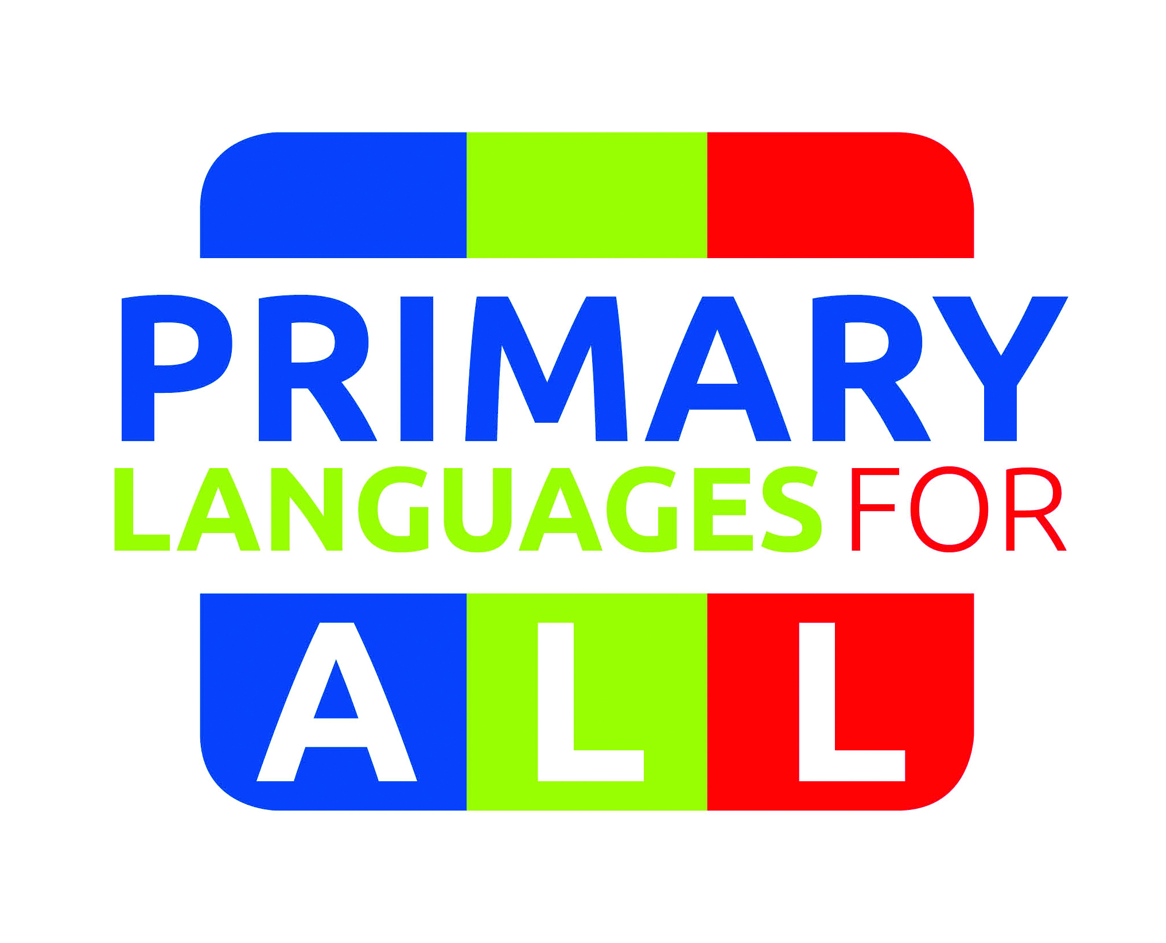 |  | in partnership    with:

ALL Yorkshire
PRIMARY Languages FAIR

Thursday, 5th June 2014
13.30 – 17.30

Sheffield Hallam University

Get Ready for September 2014!
ALL you need to know in ONE PLACE

- What are the statutory requirements?
- What will Ofsted expect to see from September 2014?
- What support is available?
- Where do I find teaching resources at little or NO COST?
- Where I can I find training and networking opportunities?

Keynote Speaker: Bernardette Holmes
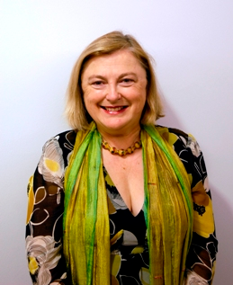
Bernardette Holmes
Association for Language Learning

Bernardette Holmes is an innovative and inspiring teacher who throughout a long career in languages, as adviser, inspector, teacher trainer and researcher has made a major contribution to languages education in England.
She is a former President of ALL, the national subject association for language teachers in England. She has been leading ALL’s work in the field of primary languages and is currently overseeing the development of ALL’s Primary Hubs all over the country.

PRIMARY Languages FAIR
Thursday, 5th June 2014
13.30 – 17.30

Sheffield Hallam University

13.30 – 14.00 Arrival and Registration
14.00 – 14.10: Welcome and Introduction
14.10 – 14.45 Bernardette Holmes, Association for Language Learning
14.45 – 15.15 Coffee / Exhibition
15.15 – 15.45 Showcase 1
15.45 – 16.15 Showcase 2
16.15 – 16.45 Showcase 3
16.45 – 17.30 Exhibition / Evaluation + Close

Information | - Inspirational Language Teaching in Primary Schools:  What it is and how to get there!  - What do the Government and Ofsted expect to see from September 2014  - How ALL can help?  Your questions answered !
Exhibition | 8 different schemes and resources  for you to see and explore in one place - some of them FREE !  For more details see attached.
Showcases | Choose 3 schemes you want to find out more about !  Listen to the authors and/or users of the resource / scheme:  How and why does it work?  For more details see attached.

A | Catherine Cheater  The French Project  Niveau Bleu | D | Ken Patterson  Théâtre Sans Frontières | F | Helen Foley  La Jolie Ronde
B | Janine Turner  Goethe Institut | E | Wendy Adeniji  ilanguages | G | Elisabeth Coyne  King Edward VII School
C | Natalio Ormeño Villajos  Spanish Embassy |  |  | H | Catherine Cheater  Golden Daffodils

To book, please complete the slip below and return to:
Eva Lamb, King Edward VII School, Glossop Road, Sheffield S10 2PW – by Friday, 23rd May.

We will send further details and joining instructions via email
(please print your email address clearly)
THIS EVENT IS FREE (though we welcome contributions towards refreshments on the day).
-------------------------------------------------------------------------------------------------------------------

BOOKING FORM

PRIMARY Languages FAIR

Name of participant __________________________________________ Tel. ________________________

Email address (please print clearly) ____________________________________________________________

Name of school or institution ___________________________________ Fax ________________________

Please list the Showcase options in order of preference (e.g. 1 = C, 2 = G)

1 |  | 2 |  | 3 |  | 4 |  | 5 |  | 6 |  | 7 |  | 8

