FREE teaching materials to train non-specialist teachers

The French Project
Niveau Bleu

- The Primary French Project aims to support any primary school that wishes to teach French throughout Key Stage 2 as part of the statutory curriculum, by providing materials that aim to exemplify the Programme of Study for Languages in Key Stage2, and to train teachers with little or no knowledge of French (language and methodology)
- It is a collaboration between:
- The Association for Language Learning (ALL)
- Network for Languages
- Institut français du Royaume-Uni (IFRU)
- Niveau bleu materials are fully aligned with the new Programme of Study for Languages in Key Stage 2, and are very simple and user-friendly. They comprise lesson plans in Word format, and PowerPoint presentations designed for use on the interactive whiteboard.

Deutsch mit Felix und Franzi

FREE Lesson Plans and Materials

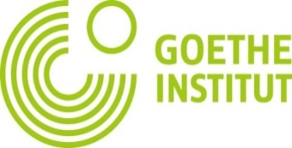

- Free fun materials for learning German at Primary Level in the format of detailed lesson plans
- Created for non-specialists as well as for those with a greater command of German
- Course enables children to develop cultural awareness of aspects of life in German speaking countries as well as creating a love for language learning
- Exciting ideas ensure progression and contain everything teachers need in order to meet the new standards
- Enjoyable exercises can easily be adapted for Key Stage 1 and even Foundation Stage
- Children will be introduced to the language of each chapter by two engaging hand puppets, a frog called Felix Frosch and a duck called Franzi Ente
- Lesson plans will be extended to a full 4 years course
- Website provides lesson plans, songs and an appendix with cultural information as well as flash card templates for free, and will soon offer whiteboard applications and animation clips, too

FREE Resources and Materials for Teaching Spanish in the Primary School

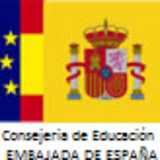
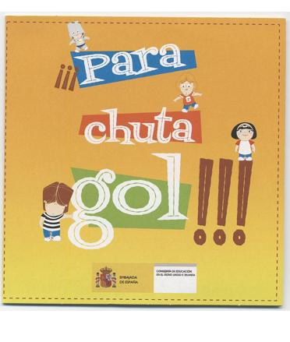

- The Consejería de Educación is the office of the Department for Education of Spain in the United Kingdom and the Republic of Ireland. It offers support and resources for the teachers of Spanish in the UK, which can be downloaded free of charge, for example:
- Sí, sí, sí - an effective tool for teaching Spanish to young children, can be used by teachers with limited Spanish proficiency; includes: lesson plans, vocabulary cards, worksheets, audio and video scripts, songs, multimedia activities and flash animations.
- ¡Para, chuta, gol! - Six PE activities that teachers can use inmediately in the classroom with their pupils, including short video clips in which Spanish primary pupils carry out the activities in their gym.
- ¡Corta, pega, pinta! - Six Art and Design activities, including short demos
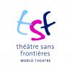

Le Tour de France

A multi-media digital resource to enrich KS2 French

- Explore France, its language and culture through this thrilling and fast-paced adventure story about the world's greatest cycle race.
- Le Tour de France, TSF's new multi-media digital programme, helps teachers to deliver language learning that is inspiring and engaging through meaningful and authentic contexts.
- Join the Sans Frontières detectives, as they cycle round France on their vélos, in hot pursuit of the Fantôme Cycliste who has stolen the Tour de France jerseys. Can they track down the dastardly villain in time to save the world's most famous cycle race?



An exciting new KS2 scheme of work
suitable for non-specialist teachers

LANGUAGES: French / Spanish
- Step by step lesson plans with objectives, success criteria and assessments
- A strong phonics focus and support for non-specialists with sound files and video clips to aid pronunciation
- Uses Talk4Writing and Kagan co-operative learning methodology to enhance interaction and progress
- Includes all resources: a work book, videos, PowerPoints, interactive stories, songs, sound files, board games, worksheets and IWB activities

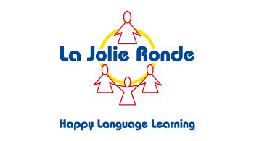

A structured and progressive course for 5 to 11+ year olds

LANGUAGE: French

- Scheme of Work written by Rachel Redfearn of Wakefield Local Authority and published by La Jolie Ronde.
- Ideal for non-specialist teachers
- lessons generally divided into 4 x 15 minute sessions to give maximum flexibility
- includes detailed lesson notes in ring binder and on CD
- has links with the Modern Foreign Language Framework
- activities for use with the Interactive Whiteboard
- CD of songs and poems

A Scheme of Work and Training Course designed for the non-specialist Primary teacher, produced, tested and implemented by Sheffield’s King Edward VII Language College and its partner primary schools

LANGUAGE: Spanish
- Includes detailed lesson plans and most accompanying resources
- Used by 5 Sheffield primary schools successfully since 2007 (including several Ofsted observations)
- Complies with the new Key Stage 2 Programmes of Study
- Strong focus on culture and cross-curricular links
- Training course consisting of six half-day sessions delivered throughout the year - designed for non-Spanish speaking Year3 / 4 teacher
- Course designed to include Spanish language, language teaching methodology and modelling of the SOW – everything to enable the non-specialist teach confidently.

Golden Daffodils:

The Catherine Cheater Schemes of Work

LANGUAGES: French, Spanish, Italian

- French Scheme of Work written by Catherine Cheater, Spanish by Steve Haworth and Italian by Adalgisa Serio and Anna-Maria Forti-Sheikh
- Ideal for non-specialist teachers
- 10 x 30-minute lesson plans in WORD format, easily adaptable
- PowerPoint presentations with sound and images, for the interactive whiteboard
- Progression mapped to the KS2 Framework for Languages
- activities for use with the Interactive Whiteboard
- links to story books, songs, finger rhymes and dance, through authentic resources
- cross-curricular links, practice and consolidation through practice parcels

