MFL / Film Summer School
2-4 July 2014

Sheffield Hallam University

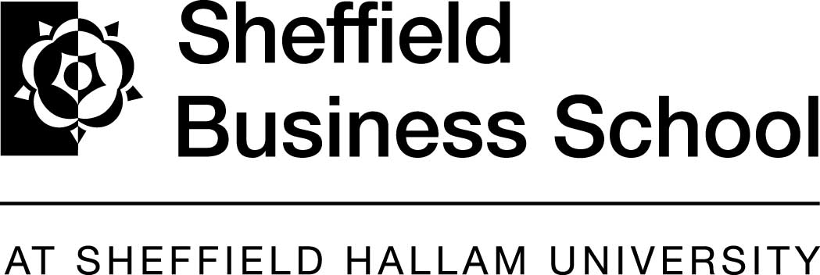

Attention Y11 students! Are you:

- interested in film?
- thinking of taking a language in the Sixth Form ?
- up for something fun and creative to do with other young people ?
- wanting to see your work on the big screen?
Lets make movies!!!


Use your languages!!!


 229 6573
email:
callison@kes.sheffield.sch.uk
Workshops Include

- Language study French, German, Spanish
- Introduction to A Level Languages
- Introduction to Film Making
- Opportunity to work with experts in their field

Contact: Clare Allison
King Edward VII School, Sheffield
 0114 229 6573
email: callison@kes.sheffield.sch.uk

MFL / Film Summer School
2-4 July 2014
Sheffield Hallam University

What is the film summer school?
- A Transition Project to help students prepare for the start of their AS-level course in FRENCH / GERMAN / SPANISH / JAPANESE

- It is a three day language and film making course for Y11 students who wish to continue studying French, German Spanish or Japanese at A Level
- It is FREE, because it is funded through Routes into Languages.
- It has run for the past four years and was very successful, culminating in the films produced being shown at the Showroom Cinema/Sheffield Hallam University
- The language work has a particular focus on the grammar covered early on at AS Level.
- Students are introduced to digital film making, particularly to the creative processes involved: story boarding, script writing, imaging etc
- Students use their language skills creatively by producing a short film, exploring their own cultural identity in the target language.
- The films will be shown at a special screening event at the Sheffield Hallam University in Sheffield.

Students who participate on the course will have to commit to attend the full three days

What are the aims of the course?
  - Encouraging students to continue with their language learning post-16

The aim is to motivate students to take up languages at A-Level and beyond by
    - engaging them in an exciting project where they can use and develop their language skills creatively
    - allowing them to work in a university environment using HE facilities
    - narrowing the gap between GCSE and A Level study
    - helping them gain confidence that they can tackle the linguistic and cognitive challenges at A Level
    - breaking down the perceived barriers to language learning Post-16

Who is behind the summer school?

The summer school is being run by Brinsworth Comprehensive School (Rotherham) and King Edward VII School (Sheffield) in partnership with Sheffield Hallam University and Routes Into Languages. The workshops during the three days are facilitated by specialist linguists, including native speakers, and film education and production experts.
This year the Summer School will take place at Sheffield Hallam University and will also offer the Y11 students the opportunity to experience language learning in a higher education environment.

To book your Y11s onto the Summer School and for any further information please email
Clare Allison callison@kes.sheffield.sch.uk
Language College Project Manager at King Edward VII School

