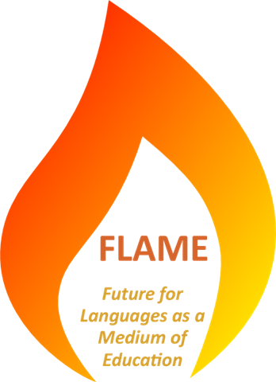
FLAME RESOURCES

THANK YOU FOR CONTRIBUTING TO FLAME RESOURCES

Please send this form to flame@all-languages.org.uk at the same time as your contribution. We suggest you send the resources by email, Yousendit or a similar service, or by providing a web link. If you have more than one unit of learning to send, please complete a separate form for each unit.

Your details

Name

Address

Telephone

ALL membership number

Institution

Resources you are sending
Name for the materials as a whole
Co-authors if any
Language
Subject
Theme/topic
Suggested age and/or ability range
Summary of the context and purpose of the materials (2 or 3 sentences)
Assiociated materials you would like to contribute or have contributed

Items submitted (add additional rows if needed)

 | Format/Medium∗ | Title (as explanatory as possible)
1
2
3
4
5
6
7
8

I have read the guide to contributing FLAME resources and have followed the advice given to avoid copyright problems. | YES / NO
Delete as appropriate

Any other information you would like to provide:

‘Unit of learning’ is used in the sense of a coherent set of learning materials with a shared overall purpose that can be used together for a period of time (anything from one lesson to 6 weeks).
For example, a previous or following unit of learning or a grammar/thinking skills activity that is relevant.
 Word document, Powerpoint presentation, spreadsheet, pdf, film, podcast, leaflet, photograph, etc. Thank you for completing the form. If you have any queries email flame@all-languages.org.uk or phone Kathy at 01858 575864

