FLAME RESOURCES

CONTRIBUTORS’ GUIDE

FLAME Resources is ALL’s next step in improving the availability of learning materials for teachers combining subject and language learning. ALL set up the CLIL4teachers wiki four years ago and many wonderful resources have been contributed. Now we hope to engage with resource sharing in a more active way, checking for quality and organising materials more effectively. As well as CLIL4teachers there will be a FLAME Resources website containing edited materials that can be used as complete units of work. To achieve this aim, we need as many resources as possible, so please do send us whatever you can. We can’t promise that everything will be posted on to FLAME Resources and it may take a while to process the resources we receive, but you can be sure that we will grateful for every contribution. We will offer constructive advice if we receive materials that need further work.

- Benefits of contributing

Members find that working with ALL is helpful for their professional development and their career, and can lead to other opportunities such as speaking at events and contributing articles for publication. The authorship of resources will be acknowledged, and they may feature in leaflets or articles produced by ALL. We will also be offering some rewards for high quality materials that we receive.

- What we are looking for

- Materials and ideas that have been trialled successfully
- Units of work with accompanying schemes of work, lesson plans and/or other guidelines; or a classroom method or activity that can be adapted to different contexts
- Materials that have already been checked for accuracy in relation to content, grammar and spelling
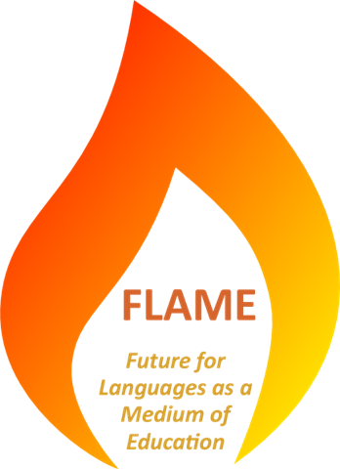
- Units of learning that use mixed media (eg. presentations, podcasts, online resources accessed via web links, or materials such as a CD or book that would need to be purchased)
- Formats that are compatible with the technology available in most primary and secondary schools
- Materials that are a continuation of ones that have previously been contributed, to create a longer sequence of learning

Ownership of contributed materials

Copyright remains with the resource creator, which means you can publish the resources elsewhere, adapt them for other purposes or use them in any way you wish. We would appreciate it if you would let us know a) if the materials are already published elsewhere and b) if you intend to publish elsewhere.

Avoiding copyright problems

For legal reasons, ALL cannot post resources online if they contain images or other items that may be infringing copyright. To avoid this:
- If you do not know the source of images or other content please replace them with ones that are clearly stated to be copyright free, or free to use if the source is attributed. Short quotations from printed material are usually allowable.
- So that we can check materials for copyright problems, please provide attributions for each image, eg. its web address. If most images are from the same source you can simply state this at the end of document. For example: “Images 3, 4 and 5 are from www.wpclipart.com. All other images: office.microsoft.com/en-us/images”. Images with Creative Commons Attribution Licenses must include the name of its creator. See flickr.com/creativecommons/ for details.
- If it is not possible to replace an image it can be substituted with a description of its content.

~ ~ ~ ~ ~ ~ ~ ~ ~

