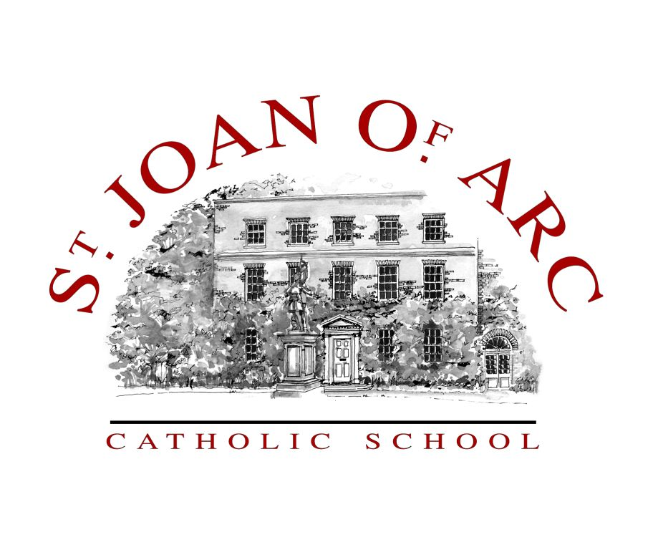  ST JOAN OF ARC  CATHOLIC SCHOOL  High Street  Rickmansworth  Hertfordshire, WD3 1HG  Tel: 01923 773881  Fax: 01923 897545  email:admin@joa.herts.sch.uk  website: www.joa.herts.sch.uk  Headteacher  Mr P Sweeney MA  NOR: 1280 including a  Sixth Form of 230        St Joan’s is a Catholic Academy | REQUIRED FOR SEPTEMBER 2012  TEACHER OF FRENCH  (the ability to also teach Italian or Spanish  would be an advantage)  The post is offered at MPS  A well-qualified and committed teacher is required to join a successful and expanding department in a heavily oversubscribed school. The post is suitable for a newly qualified teacher or an established teacher wishing to develop their career in an all ability Catholic school.  The ability to teacher Italian or Spanish would be an advantage (to be agreed at interview).  “This is an outstanding school. The strong Catholic tradition supports the very positive ethos in the school and the development of both the academic and personal development of the students.”  Ofsted, March 2011  The school has a strong commitment to professional development and ‘Future Thinking’ is at the core of our philosophy.  The post provides a superb opportunity to work in a high achieving school with an outstanding ethos.  For an application pack please visit our website www.joa.herts.sch.uk or contact the school office on 01923 773881.  Closing date for applications: 14th May 2012  “Educating for the future”  St Joan of Arc Catholic School is committed to safeguarding and promoting the welfare of children and young people and expects all staff and volunteers to share this commitment.

