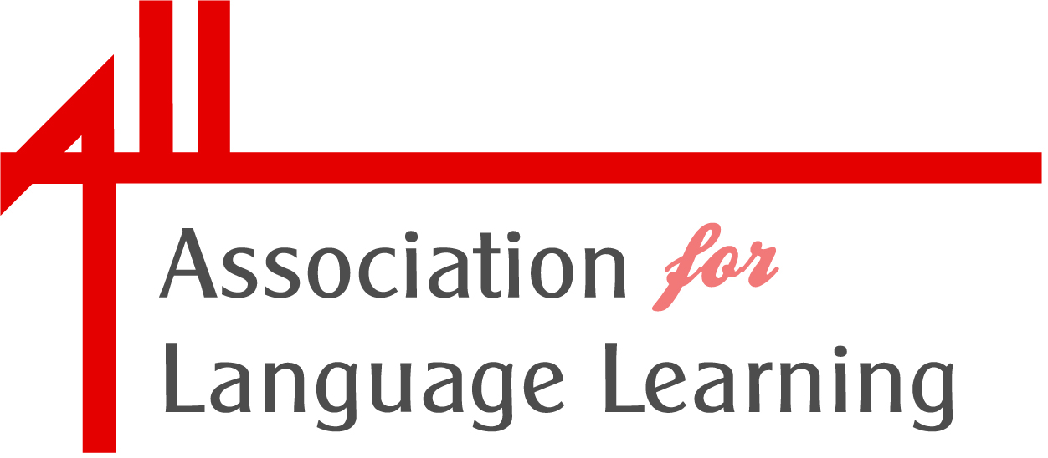 | in partnership with:  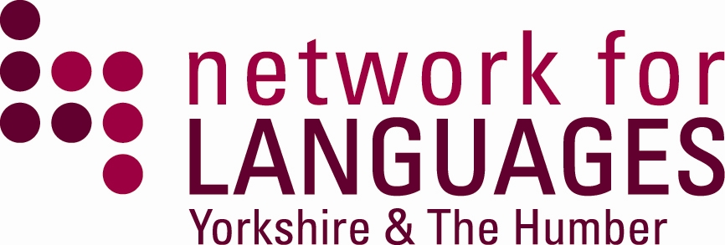

Moving forward with language learning:
Dissemination event sharing resources and ideas from Links Learning Networks funded previously by Links into Languages

York St John University
De Grey Court
Friday 20th January 2012 9.00-15.30

networks established using Links into Languages funding.

Registration: 9.00-9.15

Welcome and introductions: 9.15 – 9.20

Opening plenary – Mark Wingfield 9.20 – 10.30

“Radically different, exciting, engaging and effective language learning”

Mark will describe a teaching approach which is suitable for hard-to-reach-pupils and the Gifted and Talented. Students are involved in workshops where they learn kinaesthetically assertive techniques in the foreign language, not only improving their fluency in the use of the target language but also developing self-confidence, assertiveness and strategies to enhance self-protection. MAX training increases personal confidence and ability in the target language whilst providing essential life skills and assertiveness training at the same time. Effective Cross curricular activity mixing MFL with PSHE, Anti-Bullying, SEAL, Confidence Building and Safeguarding.

Workshop 1: 10.30 - 11.25

Break: 11.25 - 11.45

Workshop 2: 11.45 - 12. 40

Lunch: 12.40 – 1.45

Workshop 3: 1.45 - 2.40

Break: 2.40 – 2.55

Show and Tell: 2.55 – 3.20

Sharing of best practice – new ideas!

Plenary and evaluation: 3.20 - 3.30

