

In association with the



**Saturday, 22nd June, 2019**

**10.00-12:30**

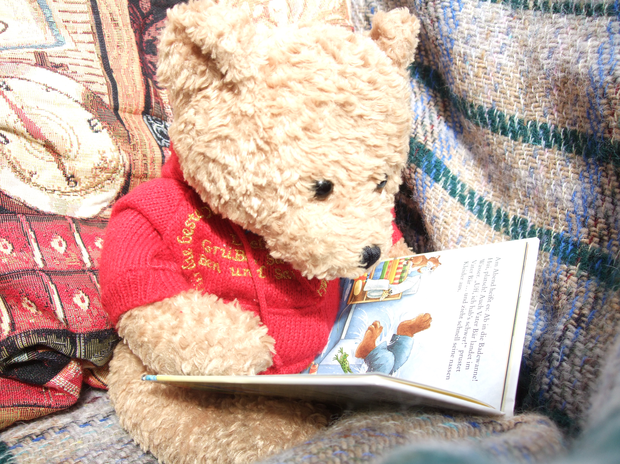

**(Abbey College, Manchester)**

**Primary Languages: Revel in Reading**

**(Nigel Pearson)**

We are surrounded by the written word, from street signs and slogans to adverts, anecdotes, cartoons, crisp packets, newsletters and novels, to name but a few. Reading is one of the main sources of language available to us, not least to develop our own language skills. Yet, there is considerable evidence that this valuable resource is not accessed by so many pupils at ***secondary*** ***level***. Why? And why do pupils so often appear not to have developed strategies to cope well with **reading in a foreign language**? Were they exposed to the written word early enough in MFL?

At ***primary* *level***, pupils are constantly developing their ***English*** **reading** **skills**, and, once they have started to crack the code, they really do start to revel in their reading. So **how does** the important skill of **Reading** in a ***foreign language*** fit into the **Primary Languages Curriculum?** Do we tap **sufficiently** into that budding enthusiasm for reading in general?

***If you teach in secondary schools*,** you ***may*** ***not*** be aware of how **Reading** ***can*** be integrated into the Scheme of Work at ***primary level***. **What sort of things do they read? Do they cope?** ***If you teach languages* *in primary schools*,** do **you** manage to include **Reading** as often as you would like to / think you ought to in your lessons? Are there any **difficulties** or **questions** faced by the ***primary languages*** teacher?

***Difficulty??***

***Materials?***

***Why?***

***Cost?***

***What?***

***How do I find the time?...***

***How?***

***Level of content?***

***How often?***

**Definitely time to invite our next speaker, *Nigel Pearson*!Nigel has been involved with *primary* *languages* for many, many years and, in 2016, he was the recipient of the *German Teacher’s Award for Lifetime Achievement*. Nigel currently teaches German throughout KS1 & KS2 at a primary school in Cheshire. Having not only seen Nigel teach, but having also witnessed, year after year, the enthusiasm and success enjoyed by his pupils, I can certainly vouch for the fact that Nigel *really* knows what he is doing. And, amongst his vast range of teaching techniques, *Reading* most certainly has a very *special* place.**

**In this session, Nigel will be sharing his enthusiasm and tips for incorporating the vastly important skill of Reading into language lessons at primary level.**

**For clarity, the session will be divided into two discrete parts: KS1 and KS2. Nigel will also allocate time for questions related to both Key Stages. Examples will be in French and German, but ideas can easily be adapted to other languages.**

**Do** come and share **Nigel**’s ***Secret Recipe*** *for* ***Revelling in Reading*!**

**Please note that all are welcome.** Not only is it **useful** to be **aware** of what goes on in language learning **before or after** pupils/students pass through our own ‘teaching hands’, but remember that **ideas** are often **easily adapted** to other stages in the language learning process; **teachers of KS3 and Adult Beginners** especially would be highly likely to pick up a few extra tricks to adapt. There is also the **added bonus** of **meeting and discussing with other colleagues**, which is of particular **benefit** to those who teach in **smaller establishments**. Why not combine it with a shopping trip and/or, if you are coming from further afield, just acquaint yourself with Manchester city centre? There is plenty to see, and the venue is *really* convenient for public transport! (For **directions**, please see **below**.)

We are very grateful to **Abbey College** for providing the venue and equipment for this event:

**Abbey College,**

**5-7 Cheapside, Off King Street,**

**Manchester, M2 4WG**

**Directions for Abbey College**:

Abbey College is located on Cheapside which is a small street off the top end of

King Street (the part that is further away from Deansgate) and off Cross Street

(behind the Unitarian chapel). It is opposite the side of *Whistles* (dress shop).

* **Coming from Marks and Spencers:** cross Market Street and head down Cross Street in the direction of Albert Square. Turn left when you see *Prêt à manger* on the corner, then take the first road on the right. Abbey College is on your right.
* **Coming from Albert Square**: walk along Cross Street to the traffic lights (where King Street crosses Cross Street); turn right into King Street and then left into Cheapside. Abbey College is on your left.

<http://www.maps.google.co.uk>

**The door will be manned from 9.30 a.m.**

Please note that the **contact phone number for the day** is: **07749 062 392 (Rachel)**

**For details of fees and how to book, please see below.**

**Fees**

**ALL Members**: **£10**

Non-members: **£30**

NQTs: **£5**

PGCE students (Non-members): **£5**

**PGCE (Associate members)** / **FLAs**: **Free of charge**

(Please make **cheques** payable to **ALL (Manchester Branch).** We regret that it is **not** possible to take payment by credit or debit card.)

It is important that we know in advance if you would like to attend. If you wish to do so, please contact Gina Hall, preferably by email: [turnerhall4952@aol.com](mailto:turnerhall4952@aol.com).

Please apply by Tuesday, 18th June, if possible.

by phone: 0161 973 1599; by post: 20, Earlesfield Close, Sale, Cheshire, M33 4UR.

**We shall need the following information from you:**

**Name (Surname; First name(s)** in that order please**):**

**Establishment:**

**Member* / Non-member* / NQT* / PGCE (Non-member)* / PGCE (Associate members)* / FLA\***

**Contact phone number (one at which you can be reached at short notice):**

**Email:**

**Receipt required: Yes / No\***

**Main teaching sector(s):** \***Primary Languages / *Middle School / *Secondary 11 – 16 / *6th Form / *FE / *HE / *Adult** *(This is to give us some idea of the potential audience which helps us and the speaker.)*

**Language(s) taught (You *may* have a nice little surprise!):**

**(*Please delete as appropriate)**

**We look forward to seeing you!**