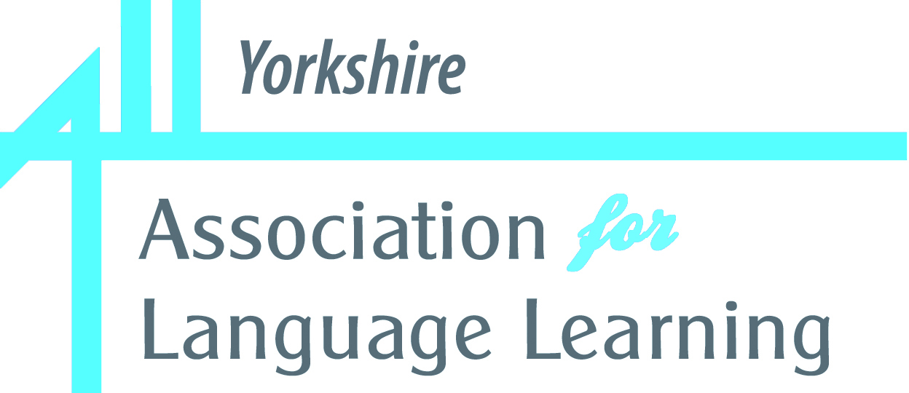 |  |  |   In partnership with:  King Edward VII School
Be inspired! Be inspirational!
Success through curiosity, enthusiasm and laughter

All sessions: 5.30 – 7.00 pm
(For Face-to-Face sessions, tea/coffee and informal chat from 5pm)

ALL Yorkshire’s Blended Winter Series
Online + at King Edward VII School
King Edward VII School, Sheffield, Glossop Road, the Library in the Old Building
+ several sessions on Zoom only

 |  |  | We keep hearing about a recruitment crisis in language teaching and young colleagues leaving the profession early on in their careers. How can we keep ourselves and our students motivated?  Language teaching can be more than operating prefabricated PowerPoint presentations, following uniform schemes of work and preparing students for final exams. Language learning is more than just rote learning, repeating parrot fashion and working towards assessments and examinations.  How can we inspire students to develop the same enthusiasm for language learning that we experienced in our own learning journey that ultimately lead us to want to teach?
This year’s ALL Yorkshire’s Winter Series will again take a blended approach. Some of the sessions will take place at King Edward VII School, whereas some will be offered on zoom.
The face-to-face sessions will allow us to engage with inspirational speakers and each other, discussing strategies and resources for language teaching, sharing best practice, exploring old and new ideas, as well allowing room for informal chats and exchanges.
Offering sessions on zoom allows us to invite speakers from further afield for whom it would be impractical to travel to us and at the same time offering part of our programme to teachers from all over the country, not just those who live in and around Sheffield.

All sessions will start at 5.30pm, and for those which take place at King Edward VII School there is also an opportunity for colleagues to meet up beforehand for an informal chat over a cup of tea or coffee.

Sessions at King Edward VII School |  |  |  | Sessions via zoom
1 | Thursday  23 Nov | Enjoy yourself!  Eva Lamb / Karen Williams |  | 2 | Thursday  30 Nov | Fun and games in MFL  Witold Wozniak
4 | Wednesday  10 Jan | Engaging students to WANT to use the target language  Julie Hall |  | 3 | Tuesday  5 Dec | The best of both worlds  Vincent Everett
5 | Thursday  18 Jan | Culture connects us  Suzi Bewell |  | 6 | Thursday 25 Jan | WoLLoW: Learning to love languages  Abigail Dean / John Wilson
8 | Tuesday  6 Feb | Creativity through film  Judith Rifeser |  | 7 | Tuesday 30 Jan | Gamification Esmeralda Salgado

Be inspired! Be inspirational!

Success through curiosity, enthusiasm and laughter

Session 1 – King Edward VII School
Thursday, 23rd November 2023

Enjoy yourself!
Eva Lamb & Karen Williams

We love our language and enjoy the company of children and young people: What can go wrong?
This session will try and capture what it is that makes language teaching and learning different, enjoyable, and fun:
- Capturing children’s curiosity and enthusiasm from the very start
- Maintaining motivation, even when the going gets tough
- Making lessons memorable
- Have a laugh!

Eva Lamb, Chair of ALL Yorkshire, has been teaching German in the UK for more than 30 years, most of these at King Edward VII School.
Karen Williams teaches French and Spanish at King Edward VII School. She is currently also a Hub Leader for the National Modern Languages SCITT and a member of the ALL Yorkshire Committee.

Session 2 – on ZOOM
Thursday, 30th November 2023

Fun and Games in MFL
Witold Wozniak

This session will explore 50 ideas for linguistic games that can be easily differentiated and applied in primary and secondary. Whether you teach days of the week, naming places in town or GCSE syllabus, you’ll find many games a great way to stimulate your students’ thinking, make them speak and enjoy your lessons.
Bring it on!

Witold Wozniak teaches French from KS2 to KS4 and is Head of French at Coombe Girls School in Surrey. He is a Lead Practitioner for Kingston upon Thames, ECT mentor and author.

Session 3 – on ZOOM
Tuesday, 5th December 2023

The Best of both Worlds
Vincent Everett

How can we engage positively with the change in thinking in Language Teaching in England?
We are being told to reform what we teach and how we teach. Vincent will show how he has tried to out-do the reforms, by keeping a balance between carefully sequenced language, alongside developing pupils' ability to use their language. Examples will be from KS3 French and KS4 Spanish, with discussion of the dilemma that we now all face in our planning for KS4.

Vincent Everett is Head of Department in a comprehensive school in Norfolk. He is a long-standing member of ALL and former elected member of the Executive Committee. He is known for his open and honest sharing of ideas and resources on twitter and on his blog, "The nice man who teaches languages."

Be inspired! Be inspirational!

Success through curiosity, enthusiasm and laughter

Session 4 – King Edward VII School
Wednesday, 10th January 2024

Engaging Students to WANT to use the Target Language
Julie Hall
This session will explore strategies to help teachers promote higher engagement in the KS4 MFL classroom, with a particular focus on the independent use of the target language by students, in both speaking and writing. We will look at some creative ideas as well as how to incorporate more cultural aspects as an integral and captivating part of lessons.

Julie Hall is a teacher of MFL and Deputy Head of Sixth Form at Ponteland High School. She delivers training both in the North East and nationally to encourage the spontaneous use of th target language in the classroom, as well as in curriculum design.

Session 5 – King Edward VII School
Thursday, 18th January 2024

Culture connects us!
Suzi Bewell

In this session, Suzi will walk you through different ways to connect with colleagues and children overseas. We’ll also look at how to integrate more TL culture into your every day lessons and how to go about setting up your own extra curricular “culture club”. Come along to find out how cultural connexions can motivate language learners and teachers alike!

Suzi Bewell is a long-standing advocate of global learning and a well-known languages teacher and trainer.
She currently is ALL’s Honorary Membership Officer and also runs a successful educational consultancy supporting languages teachers worldwide.

Session 6 – on ZOOM
Thursday, 25th January 2024

WoLLoW: Learning to Love Languages
Abigail Dean & John Wilson

WoLLoW stands for “World of Languages / Languages of the World” and is an exciting new curriculum aimed at putting joy and fun at the heart of languages teaching for children in KS2 and KS3. The WoLLoW resources and lesson content have been created to encourage children to be curious about languages, to understand the links and see the patterns between languages, and to help them to think about how a language works. We want pupils on the WoLLoW programme to love words and love how their own language works. The goal is for pupils to be filled with the wonder of how languages intermingle, how they have built on each other and how they enhance our lives.

Abigail Dean is a teacher of French and German at Norwich School. As a co-founder of WoLLoW, she is a main contributor to the curriculum design, lesson content, and resources on its website, as well as liaising with schools and other stakeholders across the UK and within Europe.
John Wilson is Head of Languages and Director of International Partnerships at Cheadle Hulme School. He is a Spanish specialist and also Partnerships Lead for The Independent Schools’ Modern Languages Association (ISMLA). He is a WoLLoW Collaborator.

Be inspired! Be inspirational!

Success through curiosity, enthusiasm and laughter

Session 7 – on ZOOM
Tuesday, 30th January 2024

Gamification
to enhance real Communication and Motivation

Esmeralda Salgado

Gamification in MFL, at any level and to practise any skill, is a perfect tool to create real communicative scenarios to develop second language acquisition and motivate learners. It develops independent skills, provides superpowers for the learning journey and is a great opportunity to reshape and personalise our teaching to the specific needs of our students. Most importantly, digital gamification and mini digital projects allow our students to take their learning experience outside the classroom. This session will provide practical examples of both traditional and digital games and purposeful tasks to make students practise the language in their listening, reading, writing and speaking.

Esmeralda Salgado is currently Head of MFL at Princes Risborough School in Buckinghamshire. She is also an Advanced Skills Teacher (AST) and a former Digital Lead. Esmeralda has taught languages for over 20 years from KS2 to KS5 in different school settings. She is a provider of workshops and webinars on MFL teaching and learning, especially regarding the use of technology and is the author of an educational blog https://mflcraft.blogspot.com, where she reflects on different aspects of MFL teaching and learning and shares resources. Above all, Esmeralda loves teaching and is passionate about languages and sharing good practice which has led her to be a 2022 Silver Award winner in the Pearson National Teaching Awards.

Session 8 – King Edward VII School
Tuesday, 6th February 2024

Creativity through Film
Judith Rifeser

In this session, we will explore the power of film(making) for language learners from KS2-KS5 to be creative and to create, giving voice to their own, personal, lived experiences. Let's explore 30 practical ideas that you can use directly in your classroom to develop pupils' skills and knowledge in the language they are learning with you, whilst nurturing their creative potential. We will look at a diverse range of examples and think about how these can be useful in our classrooms and beyond, taking the joy of learning from your lessons out to also engage parents/carers and the wider community. No need for expensive gadgets or tools, just bring your phone and start thinking about your favourite film.

Judith Rifeser has been a long-standing committee member of ALL London, was previously the ALL Deputy Honorary Membership Officer and is now President-elect. She is passionate about film(making) with language learners and teachers of all ages and from all around the world to facilitate intercultural understanding, nurture creativity and empathy, and celebrate multilingualism. Judith is one of the Co-Directors of the Critical Connections Multilingual Digital Storytelling Project. She is currently particularly engaged in thinking about the power of digital technology to build creative environments to facilitate teaching and learning at UCL IOE.

Be inspired! Be inspirational!

Success through curiosity, enthusiasm and laughter

Cost of the Series

All 8 sessions
Individuals: For the whole series, i.e. all 8 events: £ 75 (ALL individual members);
£ 150 (non-members)
Groups / Departments (irrespective of number of participants ):
For the whole series, i.e. all 8 events: £ 95 (ALL group members);
£ 175 (non-members)
Associate Members (= PGCE students): all 8 events (no matter how many you attend): £ 10

To take advantage of the reduced fee for ALL members, please take out membership prior to booking:
www.all-languages.org.uk

ZOOM sessions only
We want to enable those living too far away from joining the face-to-events to join in!
Please come along and meet us online!
ALL members: £ 25 Non-members: £ 45
Fee applies for all 4 zoom events (irrespective of how many you actually do join):

Payment Options (please tick applicable)
Bank Transfer: Association for Language Learning Yorkshire (Mrs Simone Conboy)
Account no: 22450068 Sort code: 30-99-50
Please add “A-Level” and your name as a reference
Invoice: via a purchase order from your school, addressed to ALL Yorkshire,
King Edward VII school, c/o Eva Lamb
Please be aware that there as a £5 administration charge if an invoice needs to be raised.
Cheque: payable to King Edward VII School, sent to
Eva Lamb, King Edward VII School, Glossop Road, Sheffield S10 2PW

HOW TO BOOK: Complete the BOOKING FORM (see attached) and send to

Eva Lamb, King Edward VII School, Glossop Road, Sheffield S10 2PW
or email: evalamb@hotmail.com

by Friday, 17th November 2021 at the latest.

