|  |  |  |
| --- | --- | --- |
|  | **European Day of Languages 2025** |  |

**Annual competition for schools throughout the UK** (organised in North-East England).

Together ALLNE, NfLNE and partners are once again organising an annual European Day of Languages writing competition for Schools, and in 2025 it is once more open to the whole country!

This year’s Council of Europe theme is: *Languages open hearts and minds!*

The organising committee invites language learners in any key stage to create a piece of text in a language they are learning on the theme:

Hearts and Minds

We think that **younger** language learners might explore the theme of Hearts … by showing in writing and drawing things they carry in their heart, things and people and events they care about; they might write captions or phrases using adjectives.

Linguistically more skilled learners might approach the theme of Hearts and Minds by thinking of:

* Favourite memories – what are they and why do they cherish them?
* How to keep a healthy heart and a healthy mind.
* Connecting with other people in different ways; developing empathy.
* Writing a blog interview with, or article about, someone they admire (Hearts) and getting into the mind of their idol!
* Or considering how Languages open hearts and minds!

*‘If you talk to a man in a language he understands, that goes to his head. If you talk to him in his own language, that goes to his heart.’*

The judges are always amazed at the range of interpretations learners bring to the theme! There will be certificates and prizes! The text must include words in a language or languages other than English, and could include imagery relating to the concept. The judges look for tidy and attractive presentation but prefer handwritten text; they are less interested in AI creations, but understand that some learners may need that support. (Teachers are requested to make a note to that effect, please). Artwork makes a powerful contribution, but judges will look principally at the language in the text, rather than the quality of any images. No entry can be larger than a sheet of A4 paper.

Pupils should write their name, age, language used, class, teacher and school on the back of their entry.

Please give teacher contact details on the **pro forma** below (page 3 of this document) to include with your bundle.

Please send entries to the following address: Network for Languages North East, c/o Professor René Koglbauer, Newcastle University, King George VI Building, Newcastle, NE1 7RU.

NB Entries cannot be returned, so you may wish to celebrate them before sending them in. We reserve the right to use winning entries for display or promotional purposes and potentially for publication (including online) and will inform you accordingly through newsletters or e-bulletins.

The intention is that this might form an activity in your school around the European Day of Languages itself (26th September), so the deadline for submission of entries will be: Wednesday, 9th October 2025. Vouchers will be offered to any winners identified by the judges, for each key stage, up to and including KS5. Further prizes may also be awarded at the judges’ discretion. In the event of insufficient entries of good quality in any specific key stage no prize will be awarded; the judges’ decision is final and no correspondence will be entered into on decisions. The judges are made up of the competition organisers and our supporters.

|  |  |
| --- | --- |
| Prof. René Koglbauer [rene.koglbauer@newcastle.ac.uk](mailto:rene.koglbauer@newcastle.ac.uk)  Network for Languages NE | Steven Fawkes  [steven.fawkes@ALL-Languages.org.uk](mailto:steven.fawkes@ALL-Languages.org.uk)  ALL NE |

|  |
| --- |
|  |

Hearts and Minds

**EDoL other suggestions**

Barrhead High School’s video (at the end of this recording) shows a great way of bringing in the community: <https://edl.ecml.at/Events/E20eventsuggestions/tabid/3270/Default.aspx>

From Scotland:

<https://scilt.org.uk/EuropeanDayofLanguages/tabid/5390/Default.aspx>

Resources from European Council of Modern Languages:

<https://www.ecml.at/en/Resources/ECMLresources?q=European%20Day>

At <https://edl.ecml.at/> you will find resources and activities.

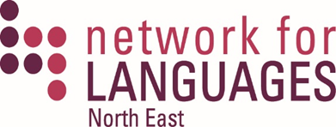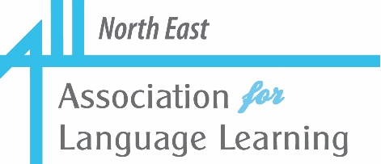

|  |  |  |
| --- | --- | --- |
|  |  |  |

Hearts and Minds

**Teacher contact details pro forma (to be returned with entries)**

School name:

Address:

Head teacher’s contact email address:

Teacher’s contact name:

Teacher’s contact email address:

*We request these details in order to send congratulations, certificates and news of prizewinners for schools to celebrate.*

|  |  |  |
| --- | --- | --- |
|  |  | F:\ALLNE\EDOL\2020\IN LOGO.png |