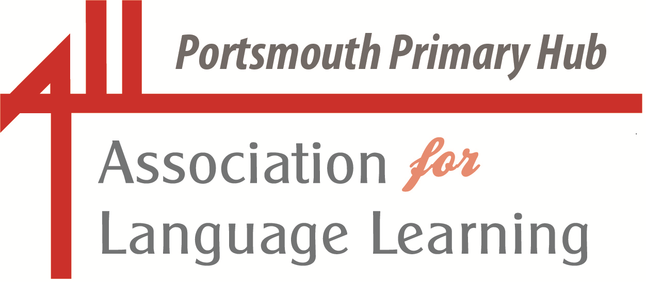ALL Portsmouth Primary Hub

Portsmouth LA Network Leads and Solent Language Network

Wednesday 4 February 2026 (online 1600 – 1700)

As part of our ongoing commitment to communicating, collaborating and celebrating as a languages community, we are delighted to present

“A smorgasbord of languages delights”



Part One 1600 – 1620: Declan Baharini of International Newcastle will persuade us to add some of the activities from Express Yourself NE: Festival of Languages to our programme for Portsmouth’s Celebrating Languages in March 2026.

Join the meeting now<https://teams.microsoft.com/l/meetup-up later.join/19%3ameeting_ZWE3ZGQ0YjYtOTE2ZS00MzY5LWE1ZTktNTlkYzRlZjEyMWEx%40thread.v2/0?context=%7b%22Tid%22%3a%22041aab0d-f500-40c9-b9c7-8441316e38d1%22%2c%22Oid%22%3a%22064837e2-2958-4a98-810e-a96f0fc2a8e5%22%7d> Meeting ID: 319 826 540 982 13 Passcode: oG6ff63S

Part Two 1620 – 1700: Continuing on this meeting link we will have an update from the local KS2 Languages and KS2-3 Transition Working Party, followed by a presentation by Bethan McHugh from Twinkl.
A Secondary Focus will continue with a presentation from Dr Kedi Simpson from 1620 – 1700 on a separate meeting link below.

Join the meeting now<https://teams.microsoft.com/l/meetup-join/19%3ameeting_MWIxZWMxZGItOTQ3ZC00Mzk3LThkZGYtZmM5M2IzNTFlYjY3%40thread.v2/0?context=%7b%22Tid%22%3a%22041aab0d-f500-40c9-b9c7-8441316e38d1%22%2c%22Oid%22%3a%22064837e2-2958-4a98-810e-a96f0fc2a8e5%22%7d> Meeting ID: 389 073 354 783 08 Passcode: Ve7zV2Uv

Portsmouth LA Primary Network Language Leads

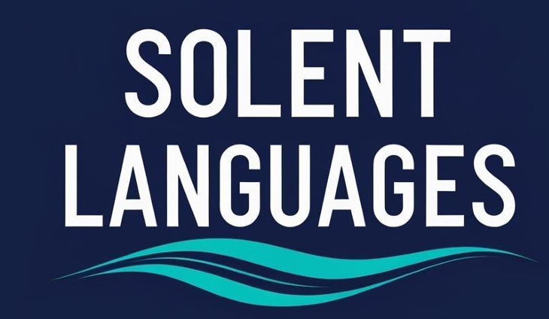
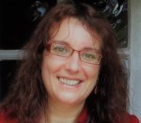
Declan Baharini, Chief Executive Officer, International Newcastle
The UK’s largest celebration of languages for schools, Express Yourself: North East Festival of Languages, began this year on Tuesday 6 January 2026.
Running until 31 March 2026, the festival offers students locally and across the UK a wide range of in-person and online events, creative projects, and classroom activities.
Declan will share some of the highlights of the packed programme and encourage us to sign up our learners to participate, particularly during our ‘Celebrating Languages in Portsmouth Week’ in the middle of March.
Declan took on the role of Chief Executive Officer of International Newcastle in October 2018. She is passionate about internationalism and creating opportunities for children and young people.
Newcastle City of Languages was the first city-wide initiative in the UK focusing on improving language learning, take up and teaching. Declan works alongside a wide range of partners to deliver and coordinate Newcastle City of Languages and Express Yourself: North East Festival of Languages.

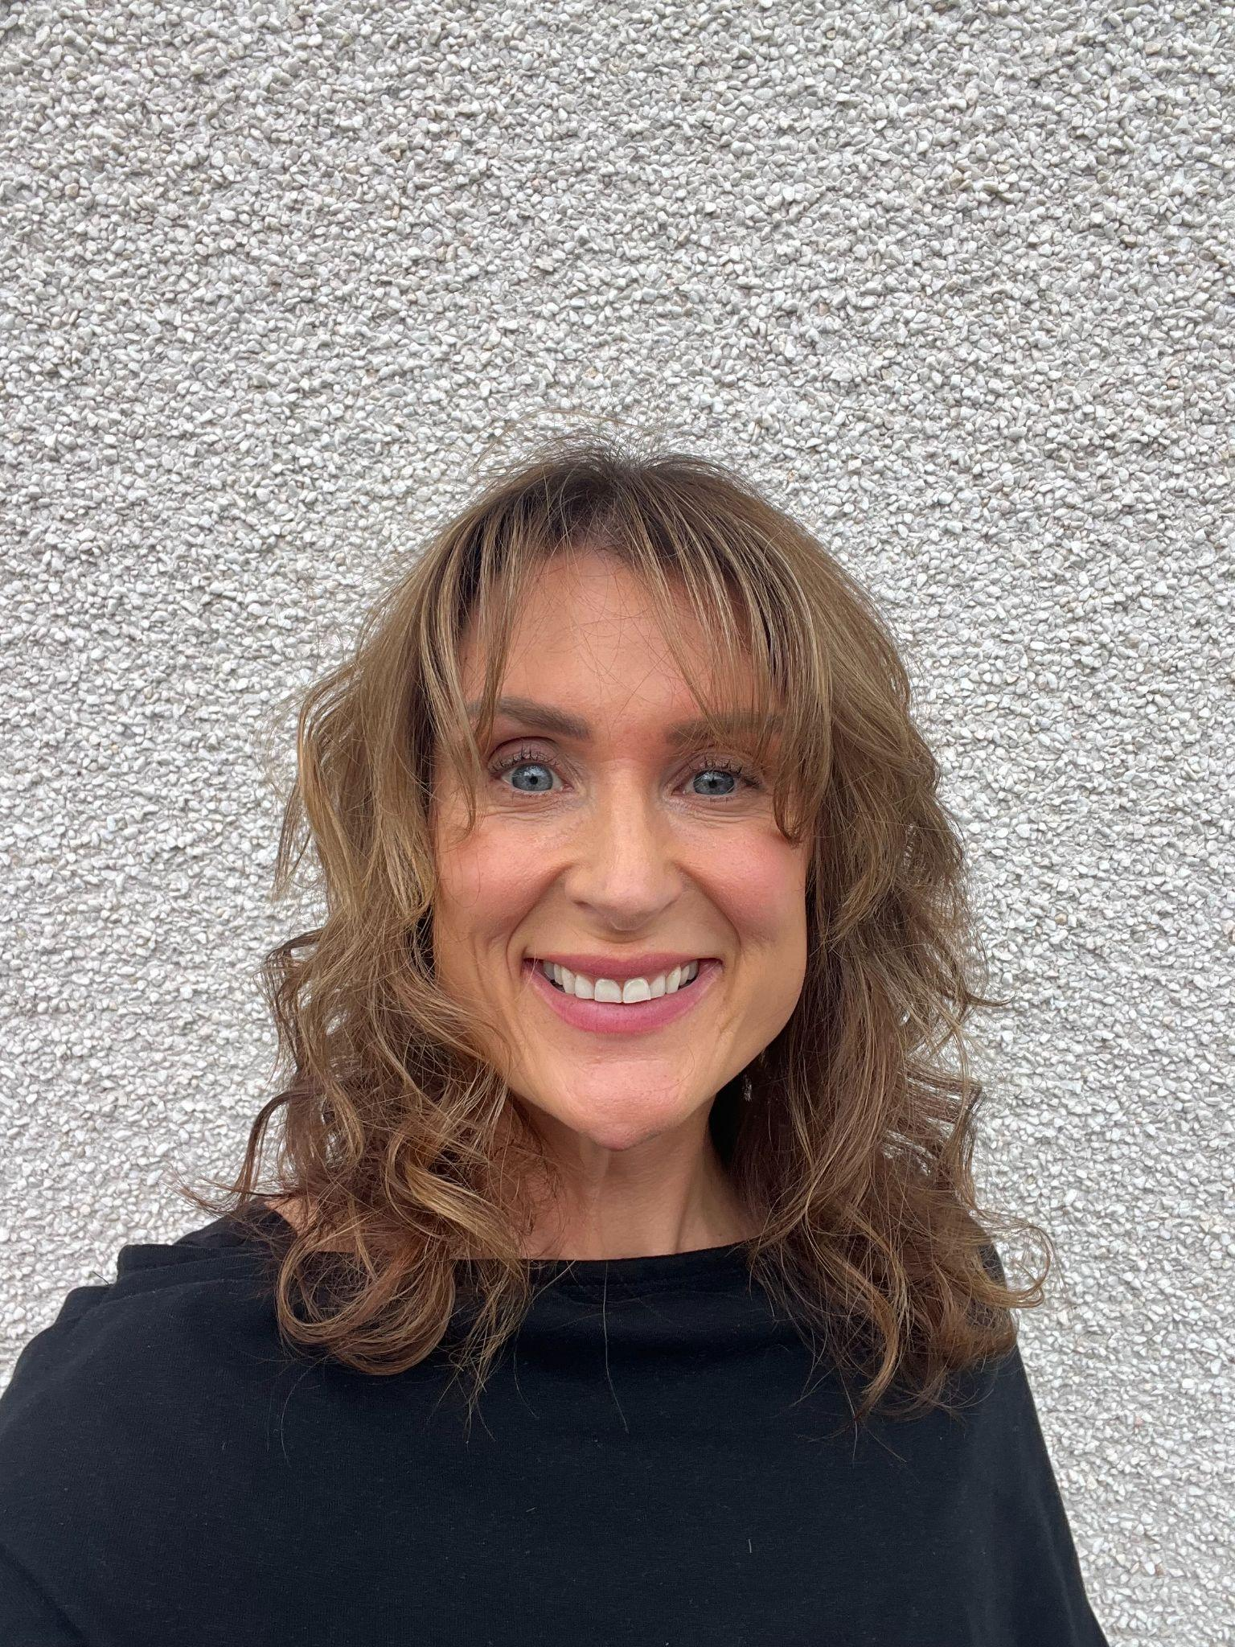
Connecting Classroom and Community with Ursa Lingua and Bethan McHugh
Making connections between classroom language learning and the wider community
can be challenging for busy teachers. In this session, Bethan will introduce Twinkl’s
free Portsmouth City of Languages resource collection and demonstrate how
collaboration and the celebration of languages can be integrated into everyday
practice. Meet Twinkl’s partnership mascot, Ursa Lingua, the Bear of Many
Languages, and discover practical ways to inspire children to value their own
languages, respect others and develop a strong sense of global citizenship
alongside a lifelong love of language learning.

Bethan McHugh is the Educational Content Lead for Languages at Twinkl. She has taught French and Spanish from KS2-KS5 in both England and Wales and spent almost a decade as a GCSE and AS senior examiner. She has also authored textbooks, revision guides and digital resources and delivered extensive CPD to teachers all over the UK. Bethan is passionate about making language learning accessible to all.


Oxfordshire languages teacher, Dr Kedi Simpson, will join our meeting to share her fascinating insights into the challenges of listening for our learners. Kedi leads a large and successful modern languages department with staff teaching three languages, French, German and Spanish to A level.

Kedi’s session is titled ’Learning to listen: errors and processes over time'. She will discuss the theoretical background to how listening works, and what we know about how students make progress in listening. Kedi will delve into some of the findings of her PhD research in which she asked students about what they really 'heard' when they were listening to French in years 7, 8 and 9. Kedi will conclude her presentation by discussing the implications of her research findings for the classroom and how we might easily tweak the listening sections of our lessons to be more useful for students and more effective assessment for learning tools for teachers.

++++++++++++++++++++++++++++++++++++++++++++++++++++++++++++++++
Our next joint meeting of the ALL Primary Hub, Portsmouth Network Leads and the Solent Language Network will take place on Wednesday 3 June 2026. Venue and theme are still to be confirmed.
And an important date for diaries: Wednesday 8 July: A cross key-stage Languages Conference at Admiral Lord Nelson School.

If there is a particular topic that you would like covered in these meetings, please do get in touch.
We plan to continue merging our language groups for future meetings as one of the steps to bring us closer together as a language teaching and learning community.

Together, we can make a difference!

