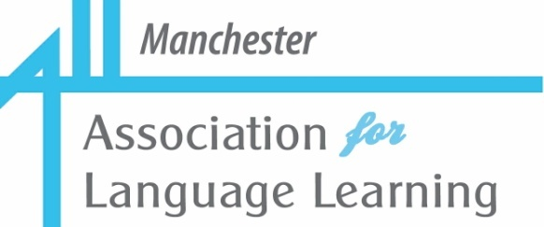



In association with the

**Saturday, 20th September, 2025**

**10.00 a.m. - 1:00 p.m.**

**(Withington Girls’ School, M14 6BL)**

**Two Part GCSE ‘Kick-Start’:**

**1 Free resources from the Oak National Academy**

**(Alice Harrison)**

**2 Show & Tell for GCSE Languages: New Specification**

**(Volunteers)**

Could you do with some **new ideas, tips** and **resources** for your **GCSE** language classes? **Join us for our *early* GCSE session to equip you with just that.**

**First of all, *Alice Harrison,* Subject Leader MFL** for the ***Oak National Academy***. **will be sharing with us information about free, optional and adaptable resources from *Oak.***

**Our second half** will be a ***Show & Tell*** dedicated to **tried and tested ideas** to help teachers and learners. Have **you** an idea to share?

**With the new GCSE exams looming for 2026, everyone is ‘in the same boat’; any extra ideas for coping with the new demands will be very welcome.**

**Individual teachers will have been adapting their usual ideas as appropriate. What has worked well? What are still the issues?**

**Do YOU have an idea or technique that is really effective with your learners in a particular skill/task?**

**Have YOU found possible SOLUTIONS to any challenges posed by the new exam? If so, please volunteer to share them.**

**In order for a Show & Tell to be successful, we need sufficient volunteers to present for 5, 10 or 15 minutes. Will you be one of those kind people? If so, please indicate this when you book.**

During this session, we intendhold our AGM. This is a ***very quick*** affair.

We are very grateful to **Withington Girls’ School** for providing the venue and

**Come and join us! For more information about the event and how to book, please see full flyer.**