ALL Portsmouth Primary Hub

Portsmouth LA Network Leads and Solent Language Network

Wednesday 3 June 2026

(f2f at Admiral Lord Nelson School from 1530, and online 1600 – 1700)

‘Together we are stronger’

In our efforts to support and strengthen our community of good practice, we are delighted to offer attendees two separate, equally thought-provoking presentations from respected and innovative languages colleagues. These sessions will provide useful and important information on challenges that face all of us in our different settings.

Part One 1600 – 1620: Language learning in the Primary Classroom: How much progress can learners make and which factors influence learning progression and outcomes? (Alison Porter, Suzanne Graham and Rowena Kasprowicz)
This presentation summarises key findings from two large research projects investigating language learning at Key Stage 2. The first, the Progression in Primary Languages (PiPL) project, is tracking progression in language learning across Years 3-6 in French, German and Spanish. The second, Digital Empowerment in Language Teaching (DELTEA), has investigated the impact of digital tools on teachers and learners of French and Spanish. Project findings make clear how children’s progression and outcomes are influenced by factors relating to the teacher and the school, to pedagogy and to learners themselves. The presentation will end with implications and recommendations for policy and practice.
NB: There will be clear messages here for you to take back for your discussions with senior management in your settings.

Part Two 1620 – 1700: Engagement in the MFL Classroom (Jonathan Mumford)
Engagement is a key driver of success in language learning. Without it, students struggle to retain and use new language. Research shows that high levels of participation, interaction and thinking are essential for progress and long-term motivation.
This practical, research-informed session will explore what we mean by the term “engagement”, what real engagement looks like in MFL and how to achieve it consistently.
NB: You’ll leave this session with clear, classroom-ready strategies to boost participation, improve behaviour and get students actively involved in their learning.
Meeting Link: Joint Meeting of ALL Primary Hub, Network Leads and Solent Language Network | Microsoft Teams | Meet-up-Join


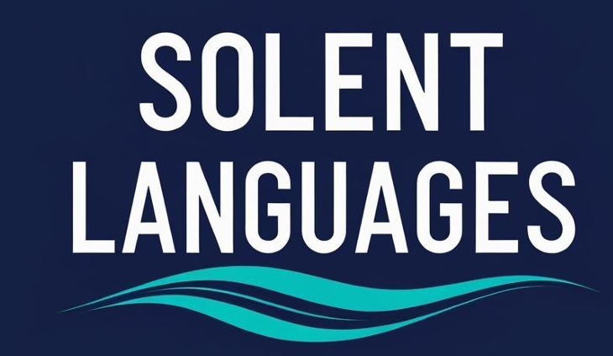
Our presenters - we are so fortunate to have them!
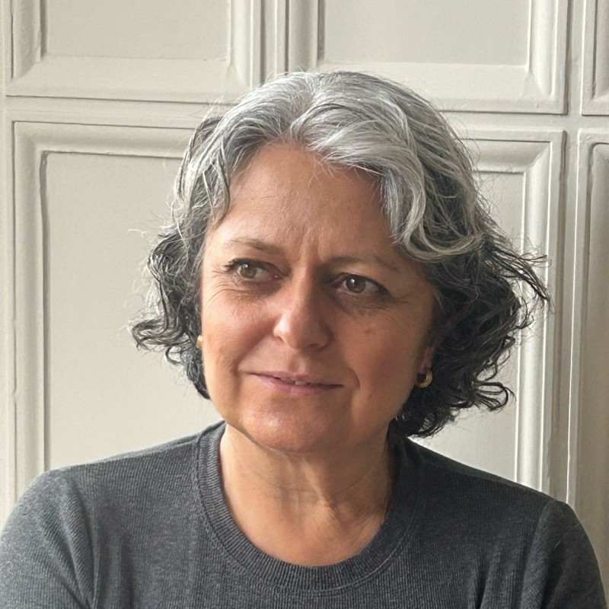Alison Porter is Associate Professor at the University of Southampton. She leads the Digital Empowerment in Language Teaching project. Since 2015 she has conducted funded language teaching and learning research in KS1, KS2 and KS3. Alison continues to work closely with classroom teachers, encouraging them to experiment with new teaching practices and resources. She is interested in how research-informed pedagogy affects learner linguistic and non-linguistic outcomes. She also investigates ways to improve languages education provision for all, for example, through teacher professional development and the use of digital tools.
 Suzanne Graham is Professor of Language and Education at the University of Reading. She co-leads the Digital Empowerment in Language Teaching project. Since 2000, she has (co)directed several research grants from major UK funding bodies and the European Commission. Her research interests concern the impact of teaching methods and classroom conditions on the learning outcomes of children and young people studying a foreign language, key stages 2 to 5. She is also interested in how language teachers can best be supported in their work, and in how young people’s motivation for and confidence in language learning can be nurtured.
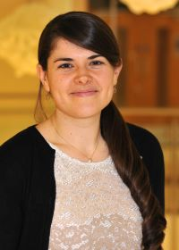 Rowena Kasprowicz is a UKRI Future Leaders Fellow and Associate Professor in Second Language Education at the University of Reading, Institute of Education, where she leads the UKRI-funded research project, Progression in Primary Languages. She has conducted extensive research investigating young learners’ language learning within the classroom and her current projects tracks children's linguistic progression throughout Key Stage 2 together with the factors that influence it.
 Jonathan is an experienced teacher, languages consultant and university lecturer, as well as a current GCSE examiner. With 19 years’ experience teaching French and Spanish in mixed comprehensive schools - including eight years as Head of Languages - he brings deep subject expertise and leadership experience to his work. He is the founder of www.jmumfordteachertraining.com, where he shares a wide range of free teaching resources and provides further information about his teacher training programmes. Working with language teachers across the UK and internationally, Jonathan delivers engaging, research-informed CPD on key themes such as student engagement, formative assessment, behaviour and creativity. He also leads the Language Links network, a global community that offers free support and CPD to language teachers worldwide.

Refreshments and an opportunity for informal chat will be available at Admiral Lord Nelson School from 1530. To help us with planning, please do let us know if you would like to join us in person. (lizlord0502@gmail.com)

And an important date for diaries: Wednesday 8 July: A cross key-stage Languages Conference at Admiral Lord Nelson School.
To sign up to attend this free event, follow this link:
https://www.eventbrite.com/e/solent-languages-network-conference-tickets-1987681881013?aff=oddtdtcreator

If there is a particular topic that you would like covered in our meetings, please do get in touch. We plan to continue merging our language groups for future meetings as one of the steps to bring us closer together as a language teaching and learning community.

Together, we can make a difference!



