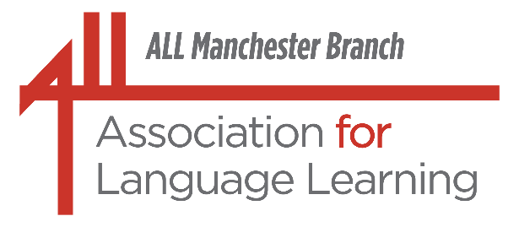
In association with the

Saturday, 27th June, 2026
10.00 a.m. - 12:30 p.m. approx.
(Withington Girls’ School)
Sing to Speak: Inspiring Learners with AI Songs
(Catherine Woodward & Michelle Massey)

After the strains, stress and sheer hard work of speaking tests, even if they were very enjoyable on the day(s), give yourself a real language(s) treat to look forward to, and join us for our next event!

As so many of you know, we always try to have an uplifting session at the end of the academic year as a ‘revitalizing boost’. This session was already on our 2025/26 programme; having experienced a talk by these two ladies at Language World, we can confirm first-hand that this will really ‘fit the bill’: not only will it be extremely useful, but also great fun! And before any of you claim not to be able to sing, please note that absolutely NO musical ability is necessary! Your learners will have more than enough ‘oomph’!

We are therefore delighted to be welcoming Catherine Woodward and Michelle Massey to inspire people with their work on songs in language learning. Catherine and Michelle have a lot in common: each with 22 years’ teaching experience, they both lead language departments in the North-West. As passionate linguists, they are truly committed to ensuring that languages are for all. They co-lead the secondary practitioner network for Oldham and Tameside, and Catherine co-leads the primary practitioner network for Oldham. Catherine is also Assistant Head for the Cranmer Education Trust, Trust Leadership Community Lead in Modern Foreign Languages and co-lead of the Kinder Language Network. It therefore goes without saying that they both love sharing good ideas and practice in language teaching. Today’s session is a prime example, and one which will inspire your learners.
Experience how AI created songs can revolutionize your MFL classroom, making it effortless to spark fluency, confidence and joy in speaking. Our NCLE project shows how songs break down barriers for vulnerable learners, igniting motivation and building lasting confidence in language use.

Join us to discover how music can inspire pupils for life and transform the way they learn languages!

If possible, please bring a laptop to use as part of the session.

Please note that all are welcome, regardless of age, years of experience in teaching or teaching setting! We are a very friendly bunch!

We are very grateful to Withington Girls’ School for providing the venue and equipment for this event:
Withington Girls' School,
100, Wellington Road,
Fallowfield, M14 6BL.
http://www.wgs.org
http://www.maps.google.co.uk

(Plenty of free parking on streets around the school;
Contact phone for the day: 07791 261 040 (Angela Siddons)
(The door will be manned from 9.30 a.m. onwards.)

For details of fees and how to book, please see below.
Fees
ALL Members: £10 ; Retired £5
Non-members: £20* ; Retired £5 (*Special fun-bargain price for the day!)
ECTs: £5
PGCE trainees (Non-members): £5
PGCE (Associate members) / FLAs: £2
We take payments on the day: cash or cheque. (Please make cheques payable to ALL (Manchester Branch). We regret that it is not possible to take payment by credit or debit card.)

It is important that we know in advance if you would like to attend. If you wish to do so, please contact Gina Hall, preferably by email: turnerhall4952@aol.com.

Please apply by Wednesday, 17th June, but early bookings are appreciated.
By text message if absolutely necessary: 07950 025 917

We shall need the following information from you:
Name (Surname, First name(s) in that order please):
Establishment:
Member* / Non-member* / Retired* / ECT* / PGCE (Non-member)* /
PGCE (Associate member)* / FLA*
Contact phone number (one at which you can be reached at short notice):
Email:
Receipt required: Yes / No*
Main teaching sector(s): *Primary Languages / *Middle School / *Secondary 11 – 16 / *6th Form / *FE / *HE / *Adult (This is to give us some idea of the potential audience which helps us and the speaker.)
Languages taught/spoken:
(*Please delete as appropriate)

We look forward to seeing you!

