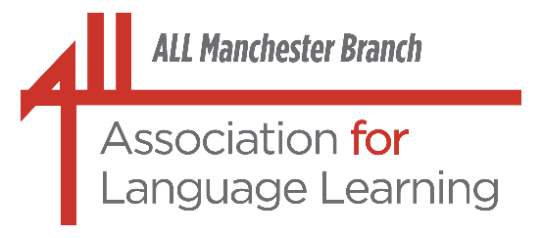

In association with the

Saturday, 10th October, 2026
10.00 a.m. - 12.30 p.m. approx.

Welcome to ALL Manchester:
Event for FLAs, ECTs and Trainees
(Withington Girls’ School)
Do you have a Foreign Language Assistant or an ECT working in your school this year? Are you an ECT or a Trainee Teacher? This event is aimed at just these people.
Members of the Branch Committee, including our Chair, Paul Wyton, will be sharing a wide variety of language activities which can be used in the classroom or in small group teaching. Word games; ways of using pictures / flash cards / PowerPoint / film clips; five minute fillers; getting pupils to use the foreign language in creative ways; ideas for Primary; tips for revision of key language for exam classes: it's all there. This could be a welcome boost of ideas for FLAs, ECTs and Trainee Teachers of Modern Languages for this year (and the next)! In order to accommodate all languages, English will be used as the main language of delivery for the session, but some examples may be in other languages.
The event will begin at 10.00 a.m. and will end at 12.30 p.m. approximately. The training sessions will be followed by light refreshments; the latter will provide the opportunity for participants to have a chat with each other and/or seek further advice/tips from committee members. This event is free of charge, but participants need to bring plenty of enthusiasm and energy with them!

Why not combine it with a shopping trip and/or, if you are coming from further afield, just acquaint yourself with Manchester city centre? There’s plenty to see!

We are very grateful to Withington Girls’ School for providing the venue and equipment for this event:

Withington Girls' School,
100, Wellington Road,
Fallowfield,
M14 6BL.
http://www.wgs.org
http://www.maps.google.co.uk

(Free parking on streets around the school;
Contact phone for the day: 07791 261 040 (Angela Siddons)
(The door will be manned from 9.30 a.m. onwards.)

For details of how to book, please see below.

There is no fee for this event but, in order to facilitate catering, it is important that we know in advance if you would like to attend. If you wish to do so, please contact Gina M. Hall by email: turnerhall4952@aol.com.

Please apply by 12.00 noon on Friday, 2nd October at the very latest.

We shall need the following information from you:

Name (Surname; First name(s) in that order please):

Establishment:

FLA* / ECT* / Trainee* (*Please delete as appropriate)

Contact phone number (one at which you can be reached at short notice):

Email:

Language(s) spoken:

Main teaching sector(s): *Primary Languages / *Middle School /
*Secondary 11 – 16 / *6th Form / *FE / *HE / *Adult

Year groups taught:
(This is to give us some idea of the potential audience to help speakers.)

(*Please delete as appropriate)

We look forward to seeing you!

