Languages in Portsmouth
An Autumn Update – September 2026
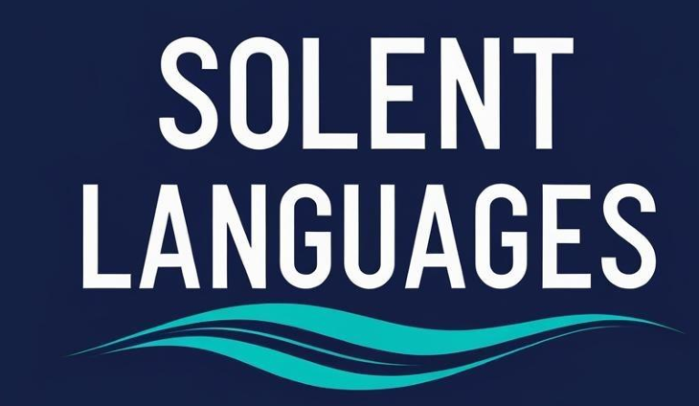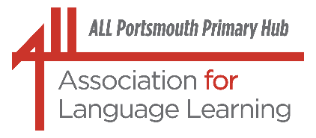
Portsmouth LA Primary Language Leads

Dear Colleagues and Fellow Languages Champions

I do hope you have been able to enjoy time to relax, recharge and ‘chill’ over the past weeks of sunshine, blue skies and high temperatures (despite the weather ‘blip’ of the Bank Holiday Weekend).

The start of the autumn term is always a time to celebrate new beginnings; new learners, new colleagues and the opportunity to try out new ideas – definitely a time for optimism and positivity.

As always, this update is filled with lots of things ‘languages’: dates for diaries, national and local events and articles that you may find of interest – please enjoy!

With best wishes, Liz, and colleagues from ;
the Solent Languages Network and Portsmouth, City of Languages

(lizlord0502@gmail.com)



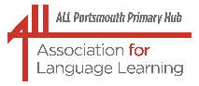ALL Portsmouth Primary Hub

Portsmouth LA Network Leads and Solent Language Network

Wednesday 7 October 2026

Our next joint CPD session will be held online on Wednesday 7 October at 1600. We will have two presentations; firstly, exciting news from the British Council about the wonderful opportunities that Erasmus+ will offer schools; secondly, Danielle Dion-Jones will inspire us and give us lots of ideas to encourage our learners to speak more spontaneously by incorporating great works of art into our languages lessons.

Both sessions will be appropriate for colleagues from across all education settings. More details and joining instructions will follow shortly.

*Further joint CPD sessions are planned for Wednesday 3 February 2027 and Wednesday 9 June 2027. Please get in touch (lizlord0502@gmail.com) if you have any suggestions for speakers or themes, or would like to present something.

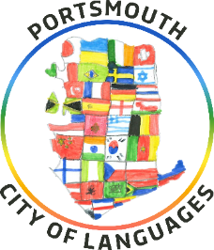

Thank you to everyone who came along to the Solent Languages Conference, which took place at Admiral Lord Nelson School in Portsmouth on 8 July. It was a truly magical experience, with amazing, informative and inspiring speakers, presentations and performances from wonderful, confident young language learners and enthusiasm and passion and energy from everyone who attended.

We hope to repeat this experience next year on Wednesday 30 June 2027, again at ALNS, so please put the date in your diary today! And do let us know if there is a topic you would like us to explore or a speaker we should invite, or, indeed, if you would like to put yourself, or a colleague, forward to share something you are passionate about.

As part of the conference programme, we were especially proud to have students from ALNS perform our Portsmouth, City of Languages song – a celebration of languages, culture, and creativity. Have you shared this song with colleagues and learners in your settings? Supporting resources can be found on the Portsmouth Music Hub website.

And another date for diaries

Following the success of last year’s focus on careers and employment and languages, a second Languages at Work day will be hosted at Admiral Lord Nelson School on Monday 5 October 2026. The morning session will be planned for secondary learners and primary pupils are invited to the afternoon session.

We have had an amazing response and the morning session for secondary pupils already has a waiting list. There are still spaces available for primary pupils (Years 5 and 6) in the afternoon. If you are interested in attending, please contact Elle Smith (esmith@salterns.org)

************************************************************************************************

And the Primary Languages Conference 2026 will have a new format this year.
Now known as, ‘The (online) Primary Languages Show’, there will be a collection of recorded presentations which ticket holders will be able to view, comment on, share ideas about and ask questions and the presenters will be able to respond. There will also be a live evening fringe event.
The theme of the conference this year is ‘The Primary Languages Journey’ and programme details and joining instructions will follow soon.

Amazing primary languages practitioners in Portsmouth and further afield – and colleagues from other educational settings too – do think about signing up to what will surely be an informative and useful event.

A quick heads-up and a date for diaries. We plan to hold our third Week of Celebrating Languages during the week of 15 – 19 March 2027.
An initial planning meeting will be held later in the autumn term. If you, or a colleague, would like to join this online meeting to share your thoughts and ideas, please do get in touch. We’ve already got some exciting plans.

If you are interested in joining the Portsmouth City of Languages steering group, our meetings will take place online at 1000 on 18 September, 27 November, 26 February, 23 April and 18 June. Or perhaps come along to the Portsmouth City of Languages Partners Meetings, which will be held online at 1600 on 1 December and 18 May? (For more information, contact lizlord0502@gmail.com or visit our website here.)

Lightning Languages supporting Portsmouth City of Languages

Remember we have the support of Lightning Languages (Twinkl) for our city-wide languages initiative. Have you checked out the free resources on the HubSpot?

https://144591076.hs-sites-eu1.com/lightning-languages-cities-of-languages

The original landing page is still on the website but this original one requires an account to access the resources, even though they are free.

Existing landing page: https://www.twinkl.co.uk/resources/twinkl-partnerships/cities-of-languages-partnerships

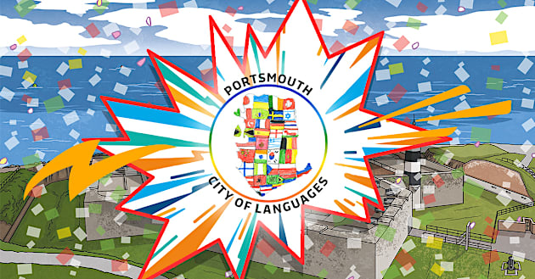

100 Voices for Portsmouth 100
Enjoy this amazing piece of work that showcases and celebrates the rich linguistic diversity of the whole community at City of Portsmouth College. Please do watch, enjoy and share with your learners and colleagues!
Additionally, you could set a challenge inviting learners to try and identify the different languages included (list below) and maybe research where these languages are spoken.

https://www.youtube.com/watch?v=Iohwk-0qJiw&t=270s
The "100 Voices" project created by City of Portsmouth College (CoPC) is an initiative celebrating the city's centenary. It features students and staff conveying messages of congratulations to Portsmouth in 100 different languages, showcasing the diverse heritage of the college's student body.
The video artefact has been produced by the college's media and visual arts departments, supporting the year-long Portsmouth 100 celebrations and inspired by our week of Celebrating in Languages and Portsmouth City of Languages.

List of languages in the video, provided by COPC:

Afghan, Afrikaans, Albanian, Amazigh, Americ, Amharic, Arabic
Bangla, Bengali, Bulgarian
Cantonese, Chinese
Dari, English, French, Georgian, German, Greek, Hungarian
Ibibio, Indonesian, Italian, Japanese, Kurdish
Pashto, Persian, Polish, Portuguese, Punjabi, Romanian
Sinhala, Spanish, Sweets Hashimi, Tamil, Tigrinya, Tiv, Turkish
Ukrainian, Welsh, Yoruba

Celebrate the 50th ‘birthday’ of Portsmouth’s International Port. 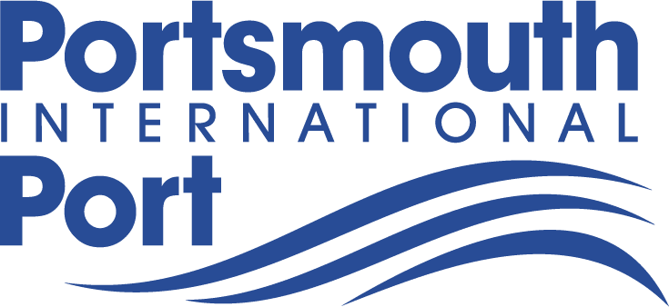 

This year the Portsmouth International Port celebrates its 50th birthday! And in the same year, too, when Portsmouth celebrates one hundred years of being a City.

To commemorate this event, young people from all educational settings are invited to prepare an artefact in a medium of their choice, and in a language of their choice - maybe a video, a poster, a leaflet or a collage - which showcases the amazing things that Portsmouth has to offer the visitors who travel through the port and may be tempted to spend time in our city. This artefact can be created using English or one of the languages that young people study or speak, and which would be helpful for tourists.
The attached posters are intended to promote the competition - please do get in touch (lizlord0502@gmail.com) for information about submitting your learners’ entries. We're still organising prizes but they will be awesome!

Please do make your learners aware of this lovely opportunity to get creative - the submission date is Friday 23 October 2026.


New project explores how pupil feedback could strengthen language teaching
Modern languages teachers across England are being invited to take part in RESULT, a new research project investigating whether pupil feedback can support teacher professional learning and improve engagement and attainment in languages.
At a time when motivation, uptake and attainment in modern languages remain a national challenge, the study will explore how student feedback collected via a Pupil Perception Survey can help teachers better understand students’ experiences of language lessons and use this feedback to reflect on and develop their practice.
Participating teachers will receive personalised feedback from their pupils, along with free resources and guidance to support their professional development.
Find out more here – please do think about taking part.
Dr Laura Molway, Principal Investigator of the project, said: “We hope this project will give language learners a stronger voice and help teachers better understand their perspectives and reflect on their practice.”
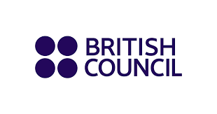
The wonderful British Council continues to offer life-changing
opportunities and experiences – check out here and see what might
work for you, and your learners!
The British Council has been appointed as the UK's National Agency for the Erasmus+ programme, following the formal agreement for the UK to rejoin the EU scheme starting in 2027.
Erasmus+ offers life-changing international opportunities for pupils and teachers to travel and collaborate with over 30 countries across Europe and beyond. You can apply as a school for funding or as a Trust for a larger scale project that might impact large numbers of pupils and teachers. Grant applications opens in November – but it makes sense to start preparing now. Here are four things you can do straightaway.

1.Sign up to the newsletter to receive the latest news about Erasmus+ events and opportunities https://www.erasmusplus.org.uk/contact

2. Check out your options. Find inspiration from case studies and explore the opportunities available over on the Erasmus+ website. https://ow.ly/5uBy50Z1G3M

3. Find an international partner. Start thinking about the kind of project you would like to do and who you’d like to work with abroad. Take a look at the guidance on how to find a school partner. https://www.britishcouncil.org/school-resources/partner/find-partner

4. Sign up for an information or partner-finding event https://www.erasmusplus.org.uk/events


And if you are interested in sharing information about Erasmus+ with your wider audiences, you may find this useful too:

- A new content pack, focused on the British Council’s campaign to encourage people to share their stories. Find here the latest External Erasmus+ content pack, with sample content, including:

- Written copy for newsletters or social media platforms, with visual assets;
- A call for audiences to share experiences of Erasmus+ to help the
British council develop a bank of inspirations stories;
- A call for people to organise events for Erasmus Days;
- Information about sports events organised by partners to inform and connect organisations.

And looking ahead to this year’s European Day of Languages (26 September, or thereabouts)

Celebrated on or around 26 September (a Saturday this year) the European Day of Languages (EDL) is a means of promoting awareness of the importance of language learning and protecting linguistic heritage. It is a day across Europe where all languages are celebrated (not a day just to celebrate European languages).

There are some lovely ideas and resources on the European Centre for Modern Languages website, with competitions, downloadable posters, activities, games and films, and on the BBC Bitesize website.
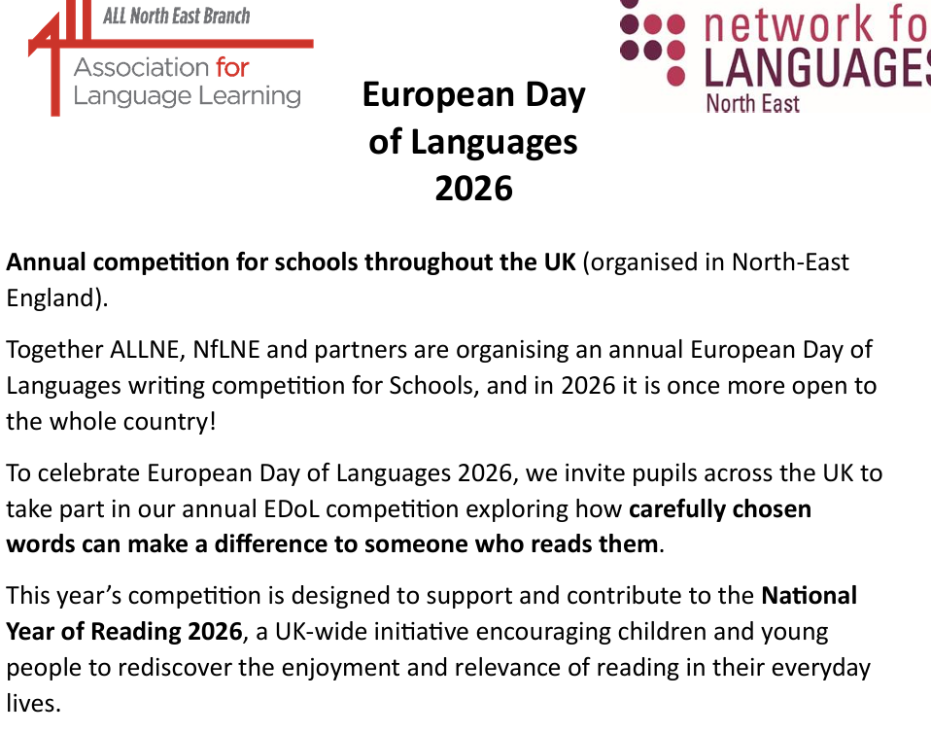
More details are included in the attachment.

Or what about this for you or your learners?

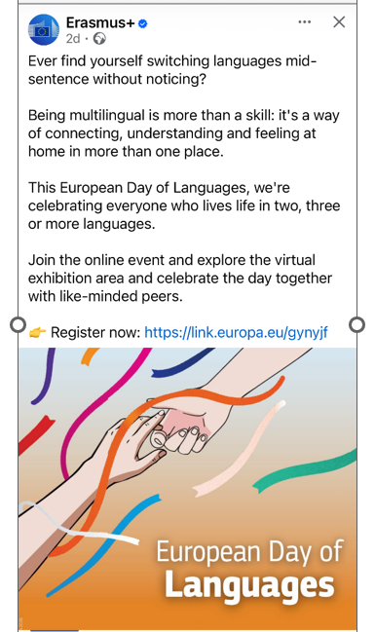

And from the Global Schools Alliance
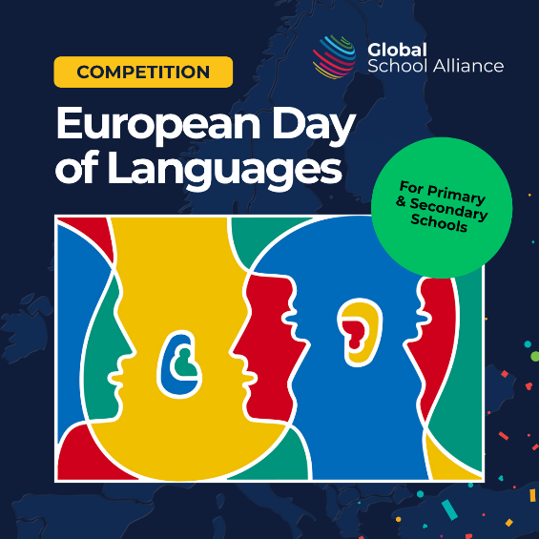

The European Day of Languages returns on 26 September, and we're excited to launch the Global School Alliance's 2026 competition for schools!
This year's theme is 'Languages Unite!'
celebrating how languages help us communicate across cultures, understand different perspectives and make everyone feel that they belong.
Students might explore:
 How languages connect people and cultures
 How learning languages helps everyone feel included
 How languages create friendships and understanding
 How different languages help make our schools and communities stronger
Every entry should include some text in a European language. Whether that's a word, greeting, phrase, poem or something completely different.
Register your school to receive the free competition pack, including printable entry templates, an assembly and classroom resources.
Entries close: 23rd October 2026
Winners will be announced: 30th October 2026
Winning entries and runners up from the Primary and Secondary Age categories will receive a certificate and an Amazon Voucher.
We can't wait to see how your students interpret this year's theme!

Enter your school



UK-German Connection is dedicated to increasing contacts and understanding between young people in the UK and Germany.

Find out more here.

Professional development opportunities

And here are just two of the amazing possibilities for teachers, both here and in Germany (and you don’t have to teach German, or even languages, to take part.)

Professional Enrichment Programme – intercultural CPD at a school in Germany

This funded opportunity is for qualified UK teachers to visit a school in Germany for 1-2 weeks and experience the education system first-hand while undertaking CPD activities based on your professional objectives.

Who can take part?
- Qualified UK teachers with a minimum of three years teaching experience
- Teachers of any subject or school type
- No German language skills required
- No partner school or existing link to Germany required

Successful applicants receive a grant to contribute towards eligible costs, including contribution to supply cover.

Application deadlines 2026-27:
- 25 September 2026 to visit in the spring/summer term, or
- 11 December 2026 to visit in the summer term.

Find more information, Q&A webinar dates, and details about how to apply here: https://ukgermanconnection.org/pp/programmes/professional-enrichment-programme/

Host a Teacher from Germany

This opportunity is for schools to welcome a teacher from Germany for 1-3 weeks at no cost. The programme is flexible and tailored to your interests, with the visiting teacher bringing an authentic insight into German culture to the school, running workshops for pupils, and engaging in professional dialogue and sharing of good practice.

Who can take part?
- All UK school types and FE colleges
- German does not have to be part of the school curriculum
- No partner school or existing link to Germany required

Registration deadlines 2026-27:
- 25 September 2026 to host in the spring/summer term, or
- 11 December 2026 to host in the summer term.

For upcoming Q&A webinar dates and for more information, visit: https://ukgermanconnection.org/pp/programmes/host-a-teacher-from-germany/

Continue your CPD journey and visit NCLE’s LEO website – full of fabulous resources!
If you are keen to keep up to date with recent research and developments in languages education, why not have a look at Language Educators Online (LEO) ?
Language Educators Online (LEO) is a free, flexible online platform dedicated exclusively to the professional development of languages teachers.
Developed by the UCL Institute of Education and funded by the DfE, this modular learning platform supports you to build your knowledge, skills, understanding and confidence in languages teaching helping you motivate and engage pupils and improve learning outcomes. LEO introduces the latest ideas and cutting-edge approaches like AI for the languages classroom. Find out more here.

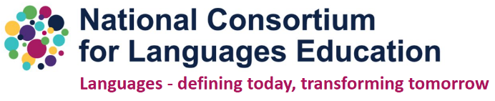

ML Exams Results 2026

ALL Co-Presidents, Anna Lise Gordon and Steven Fawkes, shared this message following the publication of GCSE results this year:

"Learning a new language (or languages!) alongside studies in many other subjects can be demanding and we congratulate all students on their GCSE results.

Languages play such a vital role in the world and your efforts over many years are a real cause for celebration. We would also like to commend students who have taken GCSE qualifications in languages learnt outside of school, perhaps in their families and other educational settings. You should all feel very proud of your achievements! We'd love you to continue with your language learning in the future - you never know where languages might take you!"

ALL’s full statement re A-Level results can be found here and for GCSE results here.

Additionally, ALL London Branch recently hosted a webinar, "Exploring the results in the new GCSEs in French, German and Spanish". This incorporated a huge amount of work on the part of ALL colleagues and stalwarts, Helen Myers, David Blow, Adam Lamb and Catherine Ames.
If you or colleagues would like access to the recording and resources, please email info@all-london.org.uk with the subject line: Request to access "Exploring the GCSE results" materials.
ALL London makes its webinar presentations freely available for professional use. If you use or adapt any part of these materials, please acknowledge ALL London and the original presenter(s). The content may not be reproduced for commercial purposes.

And, of course, we continue to have a challenge in recruiting and retaining Languages teachers.

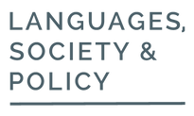

Language Teacher Recruitment and Retention in England’s Schools: Practitioner perspectives
Ann-Marie Hunter and Zhu Hua | 10 August 2026 | Policy paper

England is facing a deepening teacher recruitment crisis, with language teaching emerging as one of the most severely affected areas (British Council, 2025).

Drawing on a survey conducted by the National Consortium for Language Education (NCLE), this paper expands on the findings of Zhu Hua et al (2025) to highlight the recruitment and retention of language teachers in English state-funded schools from the perspectives of practitioners. Full article here.

And on a related theme:
Why England cannot afford to lose its international Modern Languages Teachers
(HEPI: Higher Education Policy Institute 9 August 2026))

This blog was authored by Juliette Claro*, senior lecturer in Education at St Mary’s University. Juliette is co-founder and co-chair of the UCET Special Interest Group for Supporting International Trainee Teachers and the Association for Language Learning Special Interest Group for Creativity in the MFL classroom.
*Juliette was also one of our inspiring speakers at our Languages Conference in July.
England’s Modern Languages (ML) teacher supply is at a critical juncture. Despite decades of concern about the domestic pipeline, the system is now facing additional challenges. International trainee teachers are often native speakers or fluent in the language they teach, and frequently have extensive teaching experience in their home countries or internationally. But in 2025-2026 many have struggled to secure roles in schools.
Full article here.

The Association (ALL) for Language Learning has announced a new mentoring programme.



I shared this recently but I would strongly recommend colleagues think about how they might like to get involved.

Would you be interested in supporting new entrants into our profession, or, indeed, could you share your experiences and wisdom and provide a listening ear to a fellow professional, possibly considering next steps?

Or maybe you would find it useful to bounce ideas and thoughts about your own personal professional life and journey with an experienced, supportive and non-judgmental ‘critical friend’?

“We are delighted to announce the launch of the ALL Language Teacher Peer Mentoring Programme. Participation in the programme is available exclusively to active members of ALL.

Become a Mentor with the ALL Language Teacher
Peer Mentoring Programme

*Support colleagues. *Share your expertise. *Grow as a professional.

The Association for Language Learning (ALL) Peer Mentoring Programme connects experienced language teachers with colleagues seeking support, ideas and encouragement. As a mentor, you will play a key role in strengthening the languages community and championing high-quality language education.

Get a Mentor with the ALL Language Teacher
Peer Mentoring Programme

*Talk through ideas. *Build confidence. *Feel supported.

The Association for Language Learning (ALL) Peer Mentoring Programme connects language teachers with experienced colleagues who can offer support, ideas and encouragement. It is there to help you grow as a professional, look after your wellbeing and feel part of the wider language community

Read more here.

Yet another great reason to join our professional association: this Peer Mentoring Programme is about ALL Members supporting ALL Members!

(Details about how to join ALL later in this Update)

Could a broader mix of languages halt the decline of MFL? (an interesting article from the TES 22.06.26)

GCSE entries data shows a big rise in ‘other modern languages’ – prompting calls for government to support schools to meet growing demand for qualifications in students’ home languages

Read more here.

**********************************************************************************

Learn your students’ names – properly. No exceptions.

In this powerful blogpost, Marijke Rivers-Andries argues convincingly about the importance of learning and using our learners’ names correctly. A useful reminder for the start of the academic year.

Read the full article here.

WoLLoW in context: What research tells us about language learning and multilingualism in primary education

World of Languages, Languages of the World (WoLLoW) is an educational programme for pupils aged 7–15 that seeks to broaden how children engage with language. Rather than focusing solely on learning a single modern foreign language, it encourages pupils to explore how languages work, how they are connected, how they have evolved over time, and how they relate to communication, culture, identity and society. Through activities exploring language families, scripts, word origins and multilingualism, WoLLoW also encourages children to recognise and value the linguistic diversity within their schools and communities.

As primary classrooms become increasingly multilingual and schools are rethinking the aims of language education, an important question is whether programmes such as WoLLoW reflect what current research tells us about effective practice. This literature review was commissioned to answer that question. It brings together evidence from multilingual education, primary language learning, teacher and pupil perspectives, and research on identity and belonging to examine how WoLLoW can be understood within contemporary educational research.
Read more here.

The joy and vitality of languages

This blog was kindly authored by Fiona Devine (Manchester) and Jo Fox (Newcastle), on behalf of the N8 subgroup on Modern Languages.

“We are very familiar with the story that languages are in decline and share the well-founded concern about the emergence of regional cold spots across the country due to declining numbers of students studying modern languages. HEPI, The British Academy and Wonkhe have gathered robust evidence showing that patterns and trends in formal language education are sadly heading in the wrong direction.

As the N8 subgroup on languages, we know that languages are often unavailable to students in schools and colleges before they make their subject choices at university. Limited opportunities have suppressed demand.

But interest in languages is not limited, and it is important not to forget the joy and vitality of languages too.”

Read the article here.
How useful is grammar teaching?
August 23, 2026 Steve Smith
I enjoyed (yes, truly) reading this blogpost from Steve Smith, discussing the pros and cons of teaching grammar. Given that grammar forms one of the three pillars (grammar, vocabulary and phonics) that are supposed to inform our languages teaching, it’s interesting to delve a little into what the research suggests.
Read the full article here.
************************************************************************************************
As always, enjoy the following ‘little gems’ from different social media platforms – thank you to the amazing colleagues who share these great ideas, and apologies if they are not all accredited. You may like some of these for yourself or your colleagues, and some for your learners, maybe to use as a starter task, to enhance a topic, to support learning or to act as a hook into new learning:

I love the statement included on this poster: “The best classrooms don’t choose one theory …. they combine them with heart!”
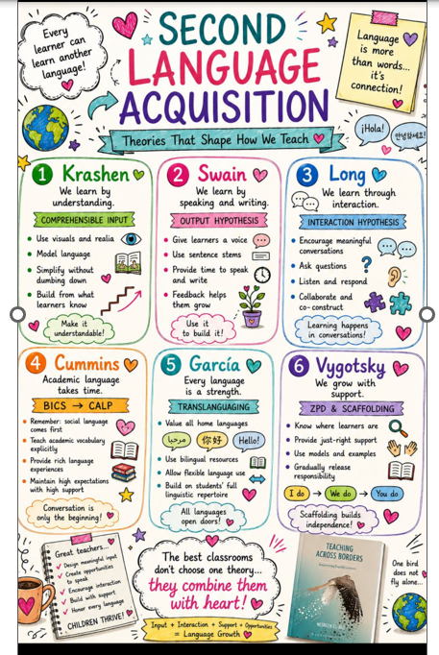
What theories of Second Language Acquisition
can you recognise here?
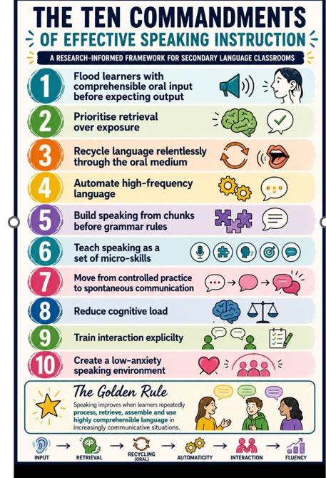

Just for fun!
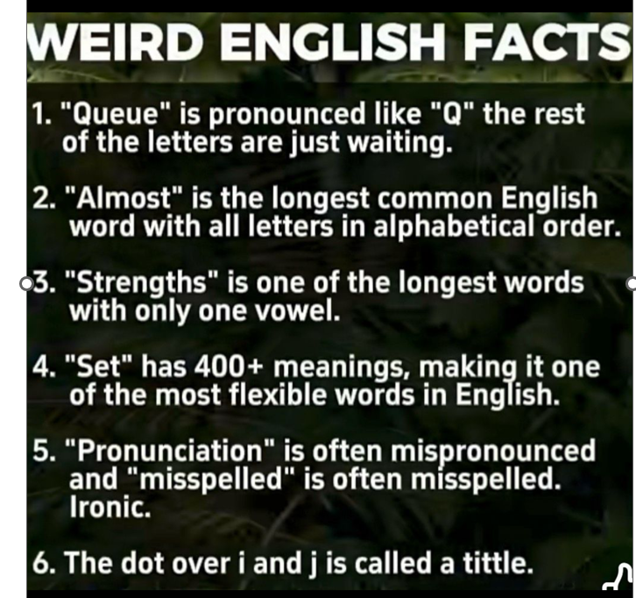

En español




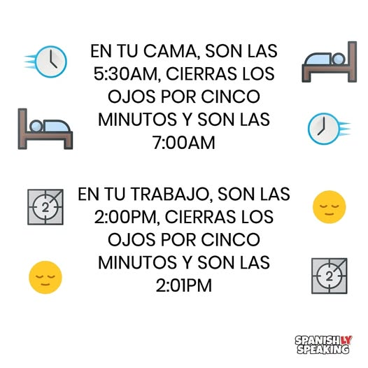

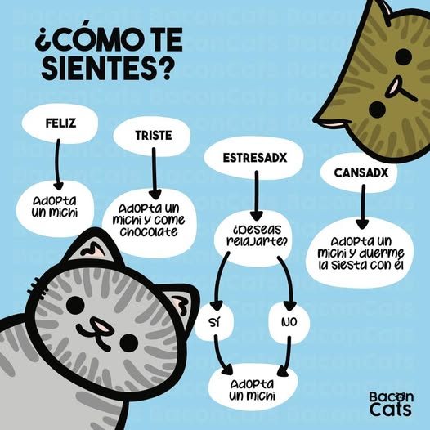
Und ein bisschen Deutsch
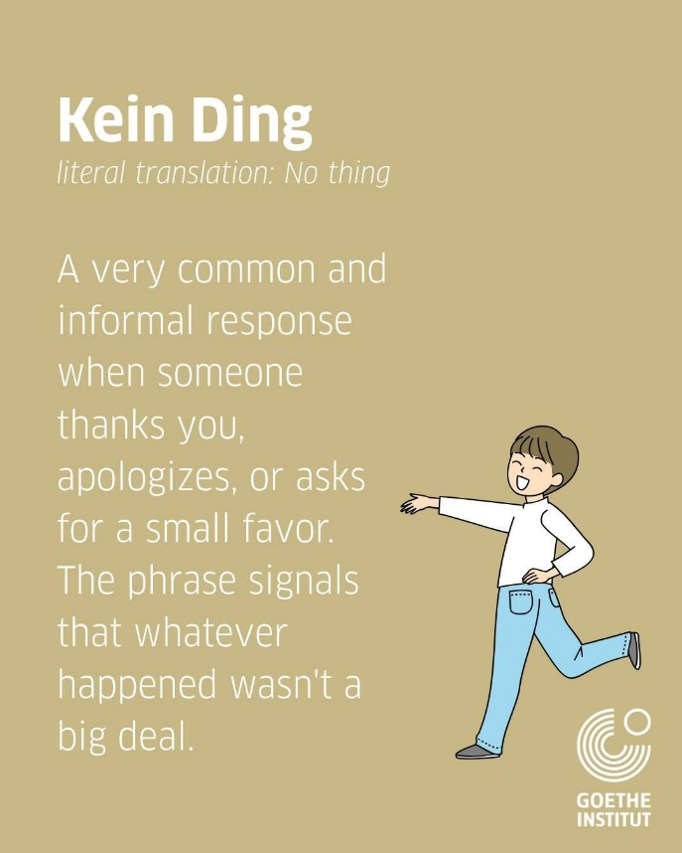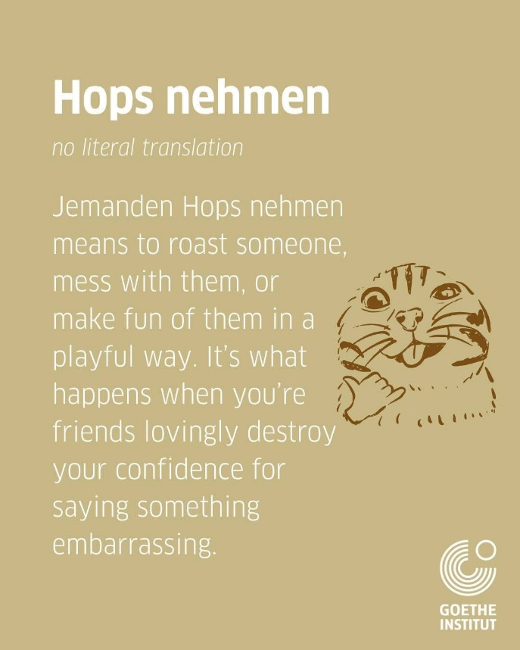
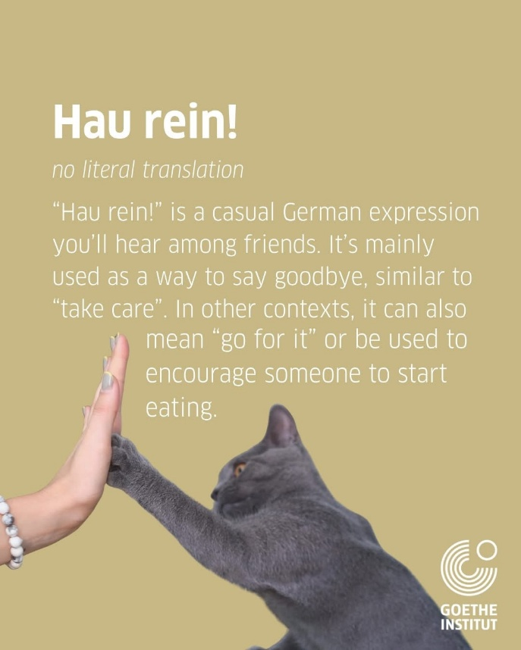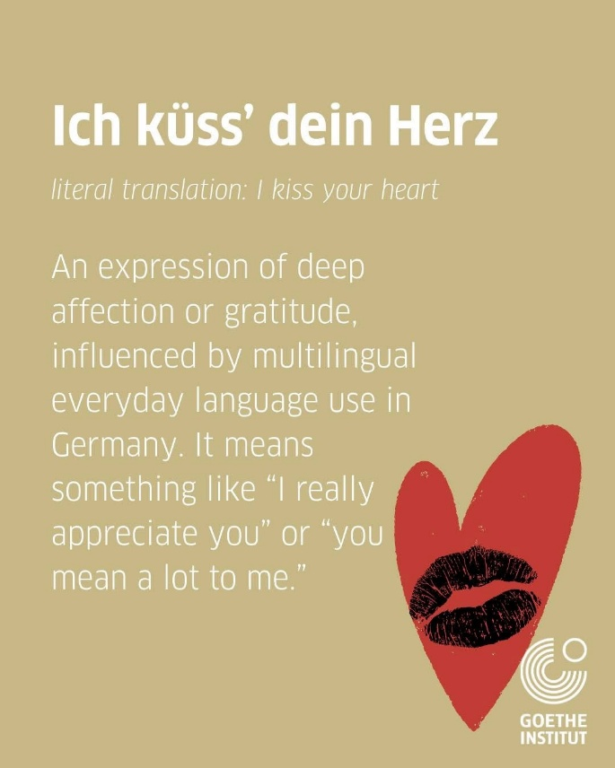



Which one will win?
(the winner to be announced in October)
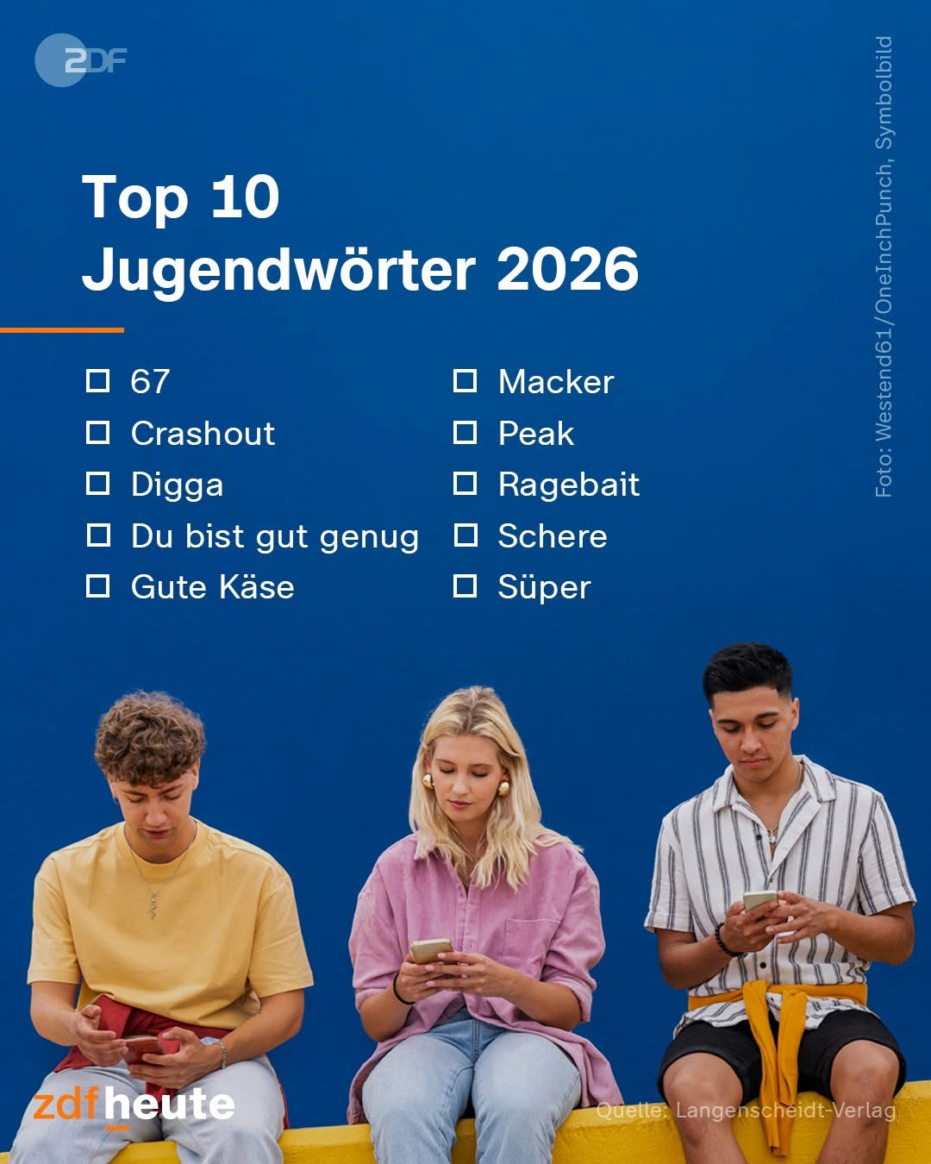

Et en français ……these are just lovely!

For discussion?


A little late (or a little early) – but cat cartoons are always good




Ooooh, do you recognise these?
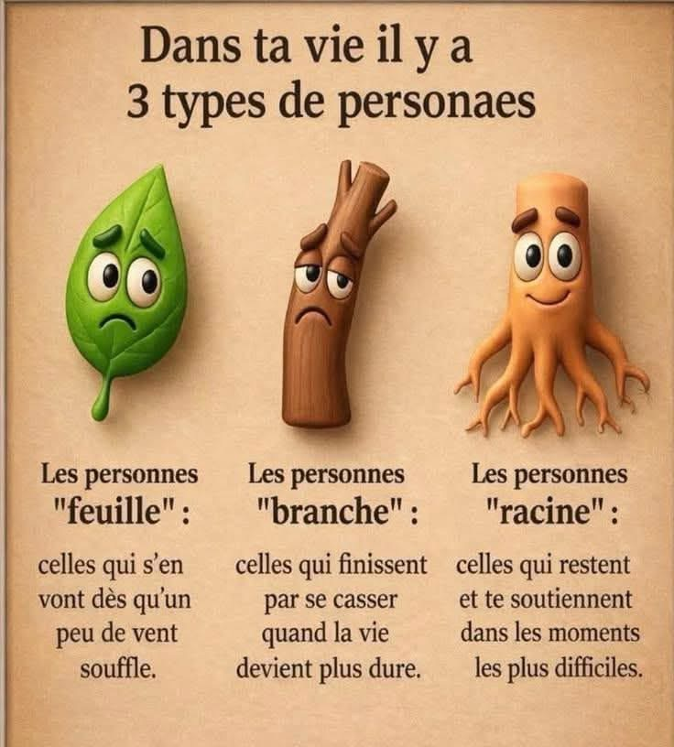

Love a good verb!

How true!
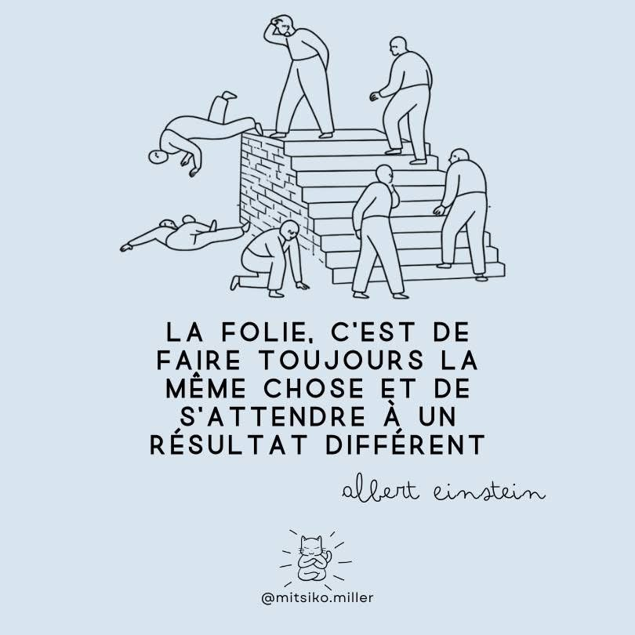

Little words can convey big messages!


The Association for Language Learning (ALL)
Members are the lifeblood of our professional association – please do think about joining this amazing community of languages champions. You can join here: https://www.all-languages.org.uk/join/becom-a-member/

Please do think about joining our association which supports languages colleagues and languages education in so many ways.

Together we are stronger!

And to end this update – as always…
Remember!

Spanish with Diana on FB


