333  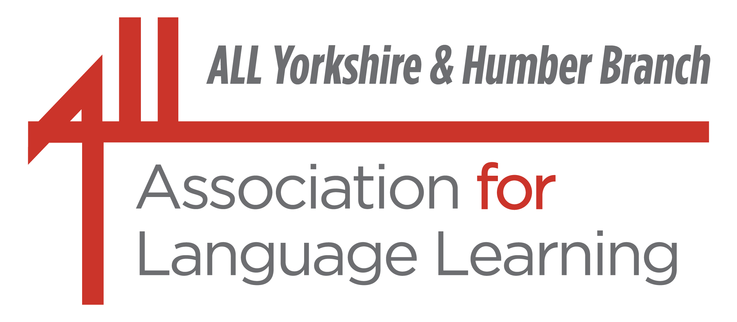  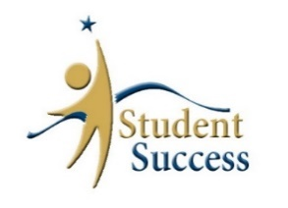 |  | in partnership  with:  

ALL Yorkshire Secondary Conference 2026

What next for Languages?
The new GCSE and the new Ofsted Framework

Saturday, 21st November 2026
9.00 – 13.30

Sheffield Hallam University
Cantor Building, Room 9020, Ground Floor

Programme

 | AQA GCSE French, German, Spanish: Exploring 2026 |  | Chloe Burrows  AQA MFL Subject  Support Manager
 | Addressing the issues: Practical Strategies for Everyday Teaching |  | Silvia Bastow Teacher, subject leader,  education consultant
 | The New Ofsted Framework: What does it mean for Languages? |  | Juliette Claro  Ofsted Inspector,  Senior Lecturer at St Mary's University Twickenham
 | Erasmus+ - It’s back! How to access European funding for international visits and projects |  | Clare Allison Development Officer, HHCL, NCLE
Cost: £ 75 ALL members
£ 5 PGCE, if an ALL member
£ 150 non-members
£ 15 any additional colleagues from the same school

This includes the cost of coffee on arrival and light refreshments at break.

ALL membership can be taken out online – prior to booking:
http://www.all-languages.org.uk/

333

What next for Languages?
ALL Yorkshire Secondary Conference

Saturday, 21st November 2026

The speakers:

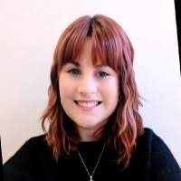 | Chloe Burrows is Subject Support Manager for Languages at AQA (Assessment and Qualifications Alliance), working with UK schools and colleges delivering GCSE and AS/A-Level Languages qualifications. The AQA Subject Support team helps teachers delivering modern foreign languages specifications in a range of ways from one-to-one support, the creation of resources, and the provision of national training and support sessions. Prior to her role at AQA, Chloe spent 8 years as a classroom teacher teaching KS3 and KS4 French and Spanish and leading on KS4 French curriculum planning.
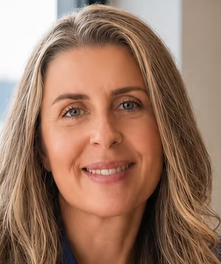 | Silvia Bastow is Subject Leader for Modern Foreign Languages at Ercall Wood Academy, a council member and HMO for the Association for Language Learning, and an author with over 20 years’ experience in secondary education. She is passionate about language teaching, curriculum development and supporting excellence in MFL education. She is a popular speaker at ALL events and shares her experience and resources via her website: FrauBastowMFL | Professional development for languages teachers
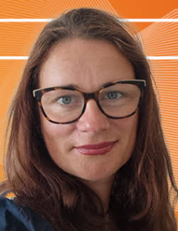 | Juliette Claro is a Senior Lecturer in Education at St Mary’s University, Twickenham, where she acts as the Secondary PGCE MFL Lead. She has over 20 years of experience teaching in mainstream secondary education and working in senior leadership. In her role as an Ofsted Inspector she has to ensure schools meet national standards. However, she is also a prominent voice in the UK language education community, offering a nuanced perspective on the impact of inspections and advocates for creative and culturally immersive teaching models. She is the co-founder and co-chair of ALL’s Special Interest Group on Creativity in MFL. This session will be delivered via a pre-recorded presentation.
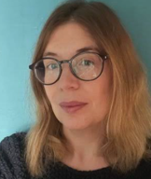 | Clare Allison is Development Officer for Home Heritage and Community Languages at the NCLE (National Consortium for Languages Education, University College London) and a member of the ALL Yorkshire Committee.  Prior to her national role she was Languages Project Manager at King Edward VII School in Sheffield, in charge of, for example, HoLA and many Erasmus and Comenius Projects. She is a founder member of Sheffield City of Languages and is very keen to support Sheffield schools with accessing European funding for international visits and projects.

To book for the ALL Yorkshire Secondary Conference, please complete the slip below and email to:
evalamb@hotmail.com
by Friday, 13th November 2026.
-----------------------------------------------------------------------------------------------------------------

 | BOOKING FORM  ALL Yorkshire Secondary Conference 2026

Name(s) of participant(s) ___________________________________________ Tel. ____________

Email address _________________________________________________________________

Name of school or institution ________________________________________________________
I am an ALL member I am not a member I am a PGCE student
I will pay by bank transfer I will send a purchase order via my school
Please note we cannot send an invoice without a purchase order issued by your school.
Bank Transfer Association for Language Learning Yorkshire (Mrs Simone Conboy)
Account no: 22450068 Sort code: 30-99-50
Please add “Conference” and your name as a reference

Invoice via a purchase order from your school, addressed to ALL Yorkshire,
King Edward VII school, c/o Eva Lamb

